# configure Kafka_config details from the detals obtained while configuring kafka

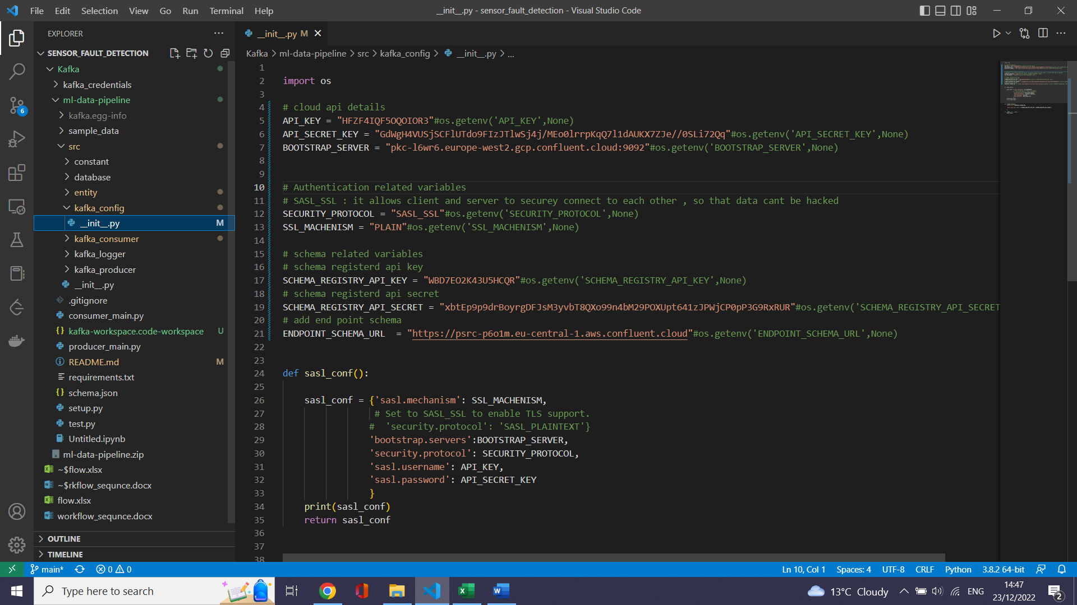

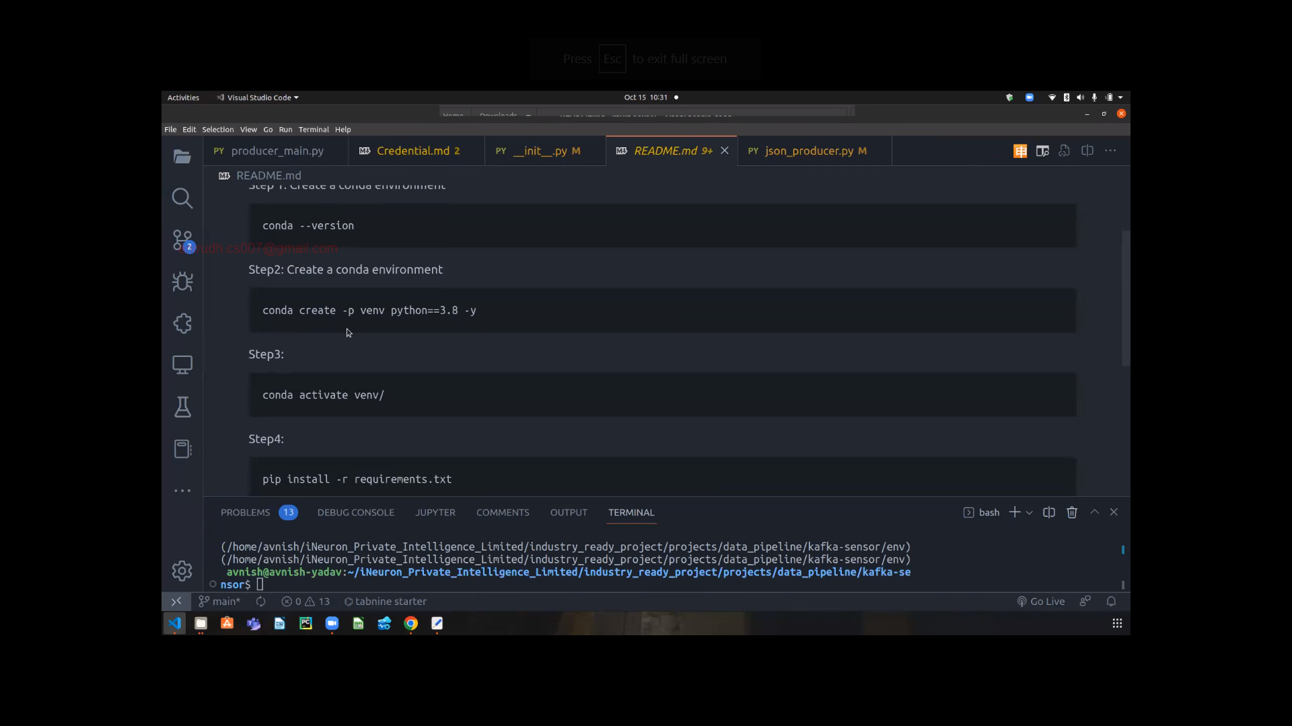

Producer.py

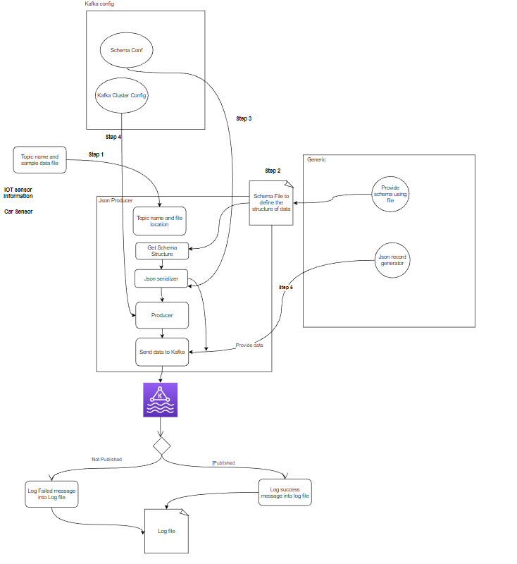

# The function to create the schma which was specified in json format:

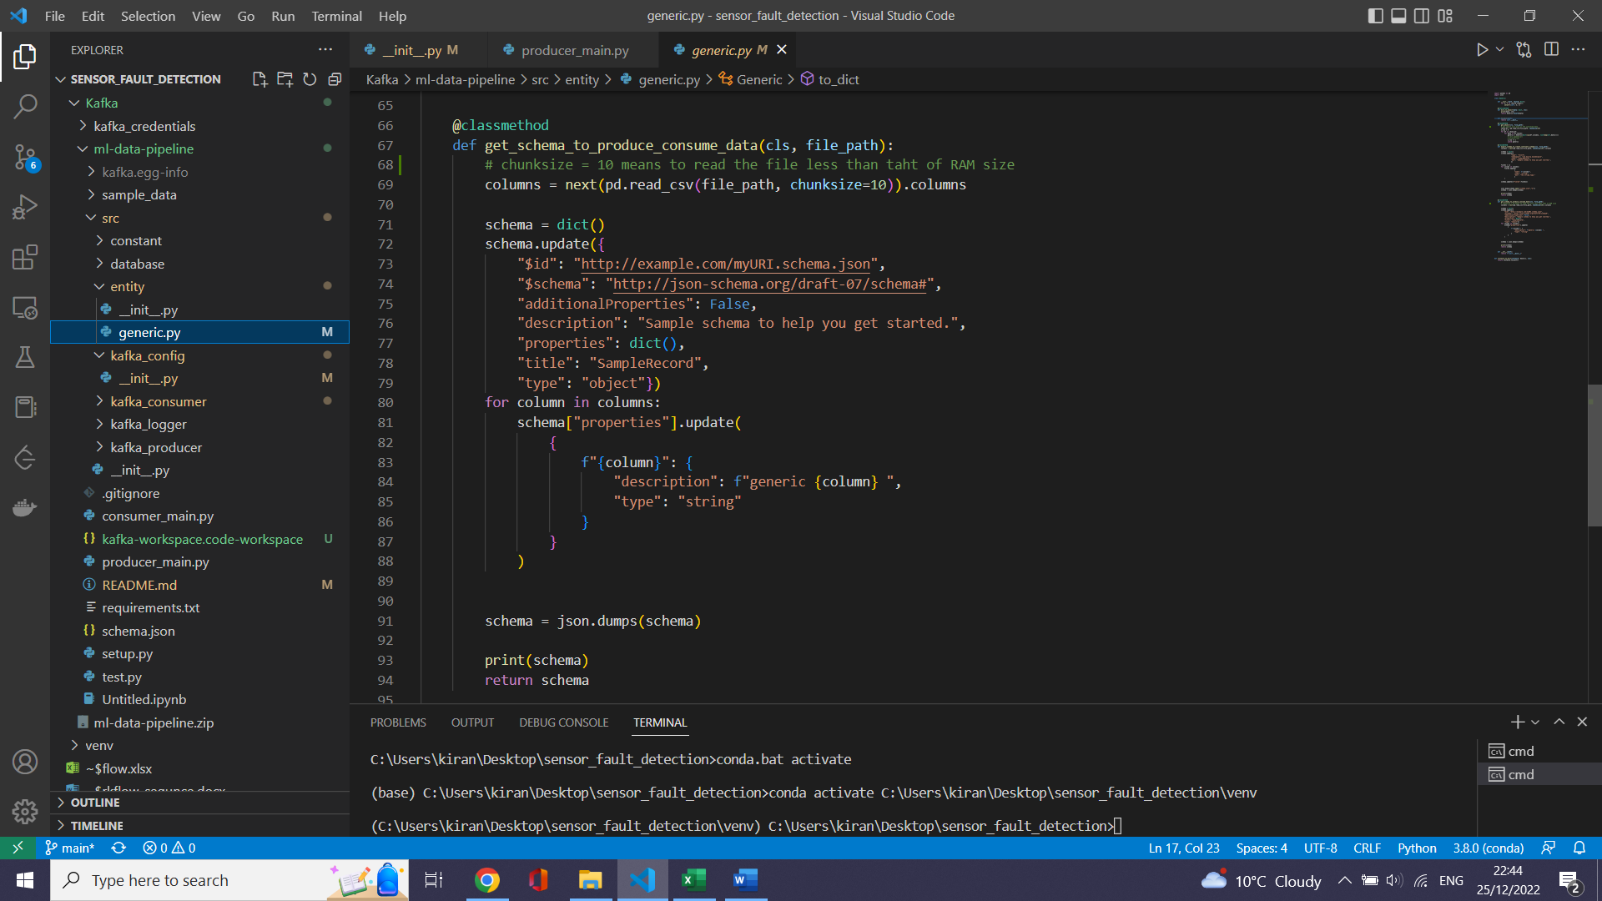

# get_object will convert the data of each row in csv file to the Json format

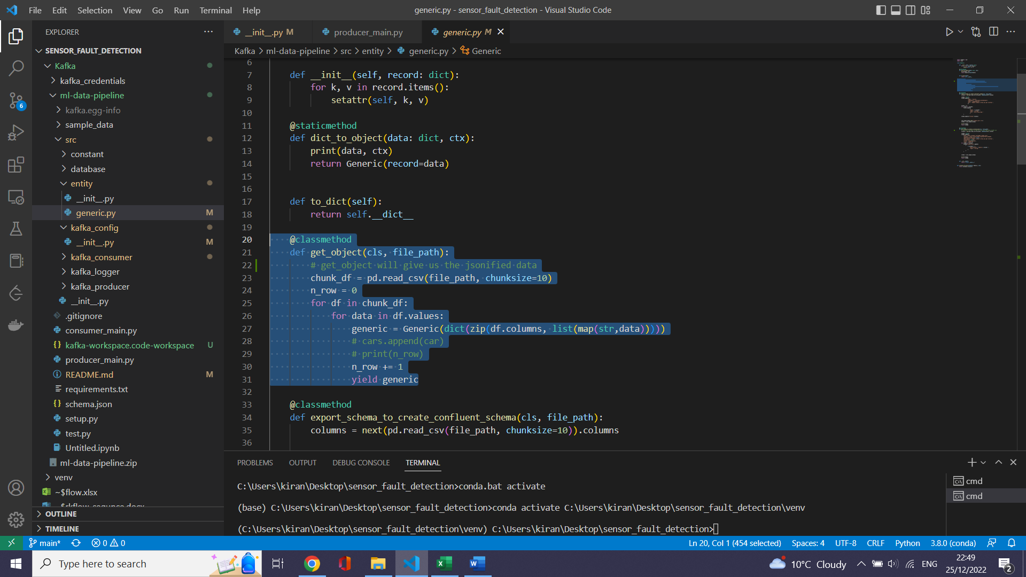

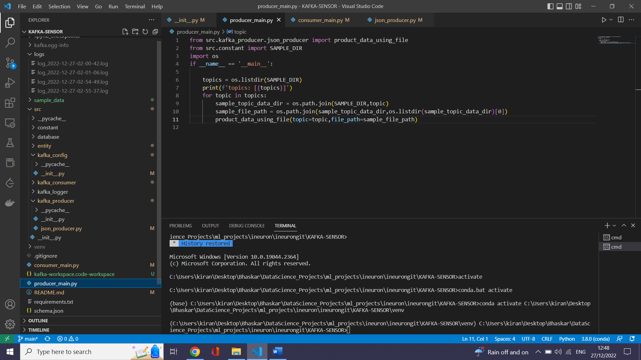

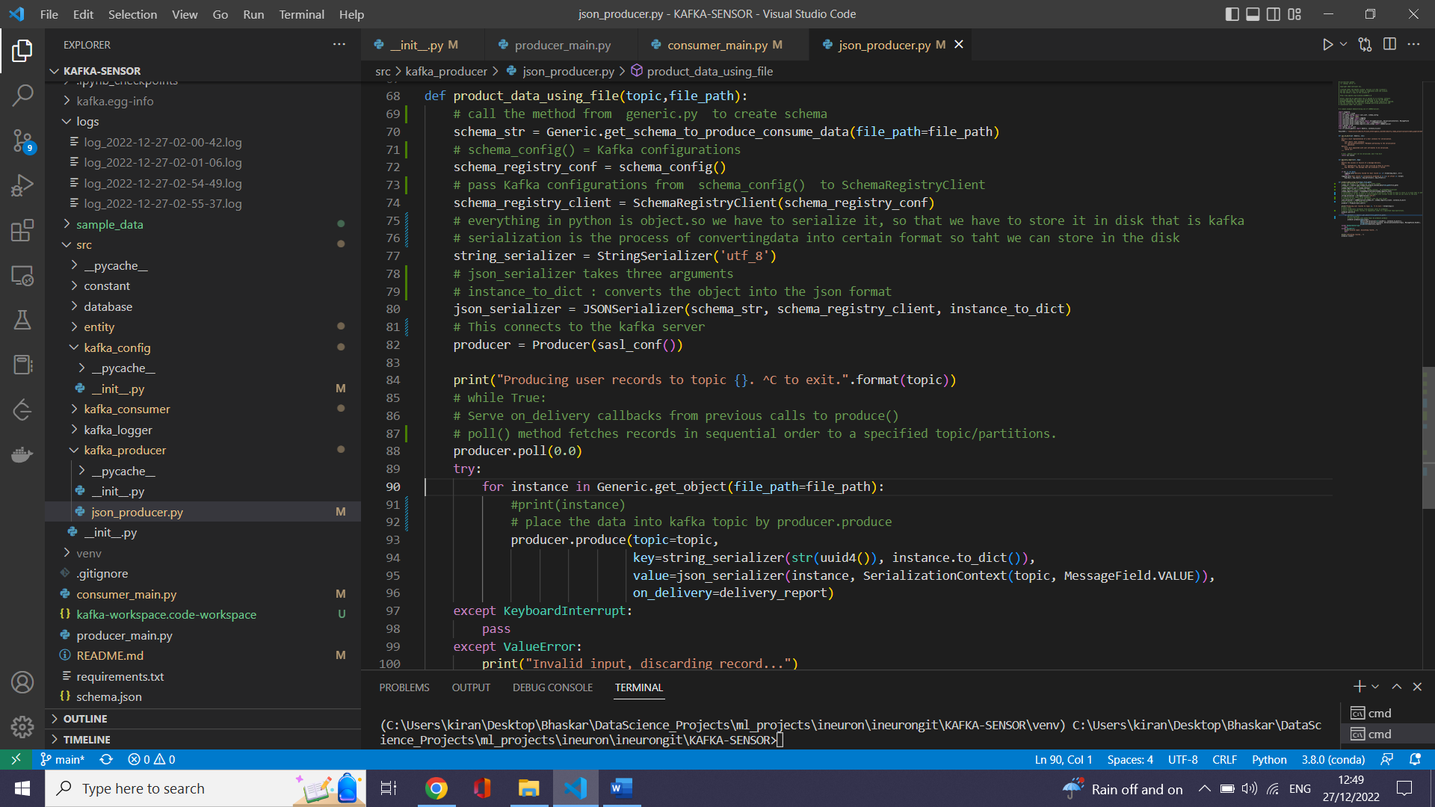

--Clone your github into ur vs code

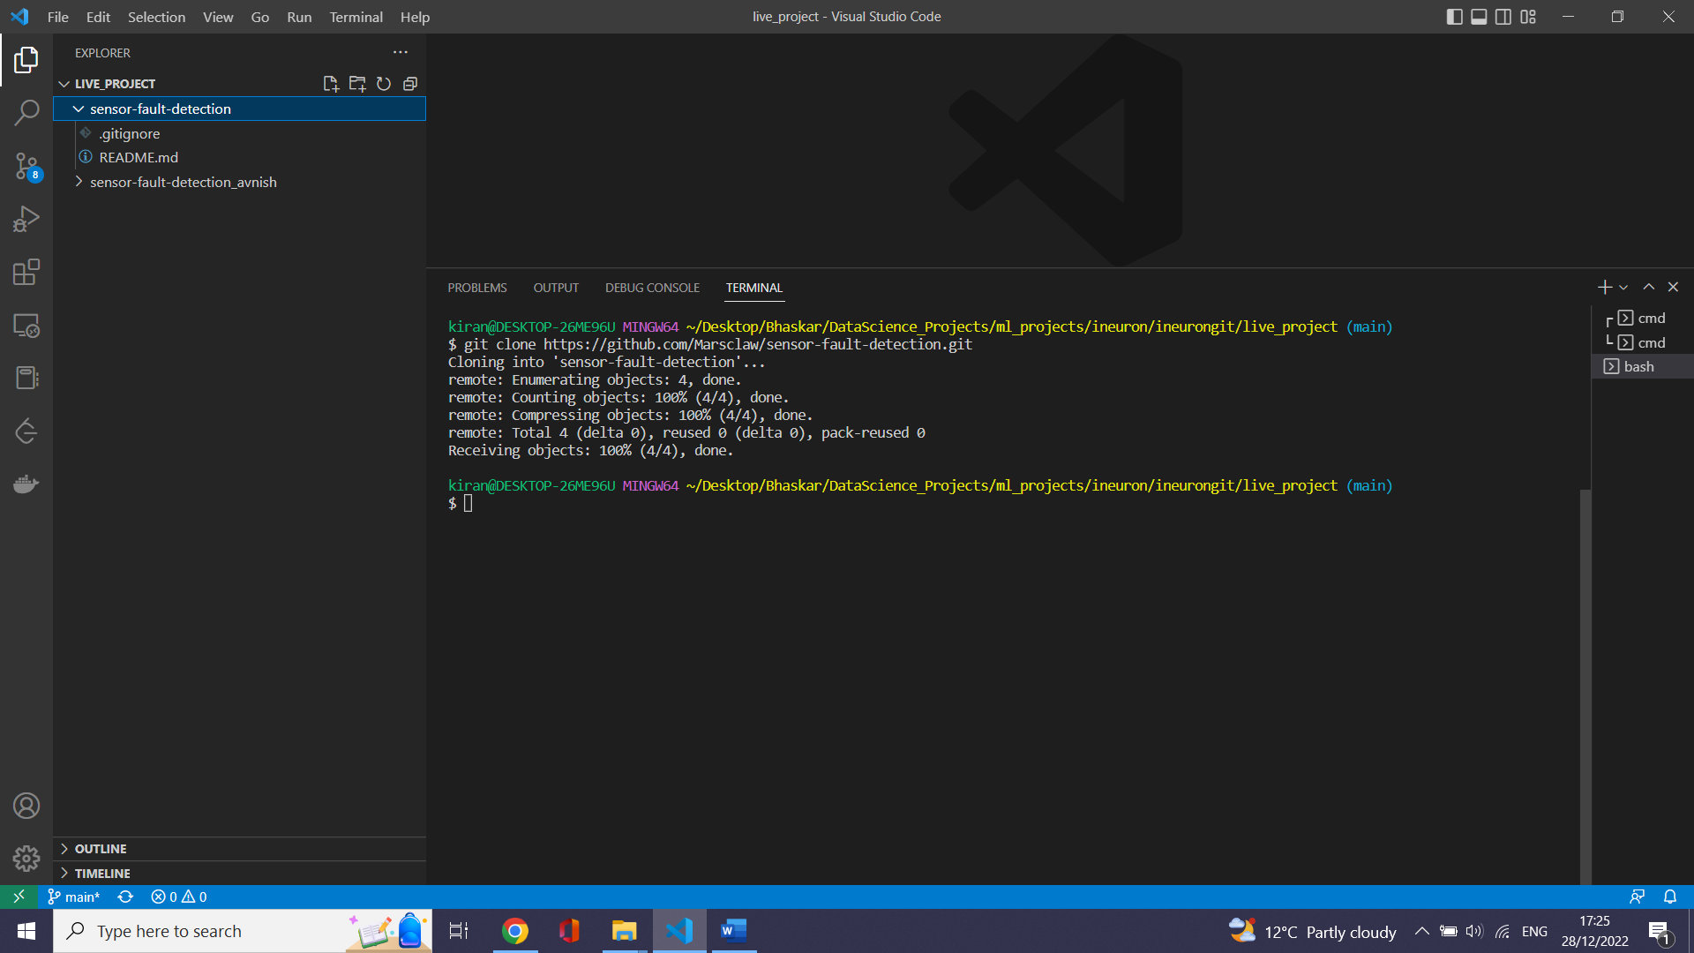

--create environment

Conda create -p venv …………………………………

Activate environment.

* Create setup.py file(to increase code portability.Sometimes code will work on one machine and sometimes it wont work on another machine. To avoid this we use setup.py …..Or sometimes we want to share the code to others or we want to publish it to internet .To do this we use setup.py )
* 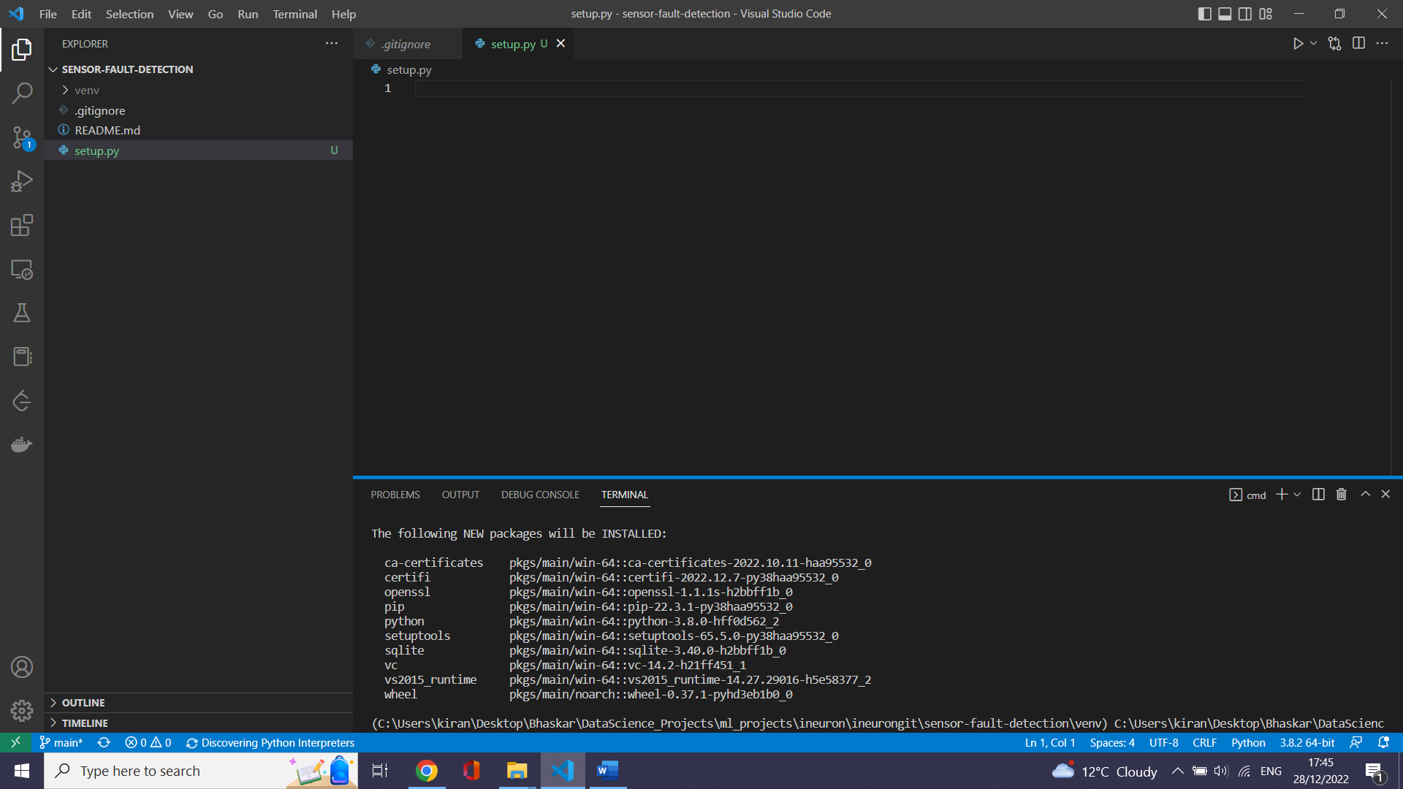

--check all the available libraries installed

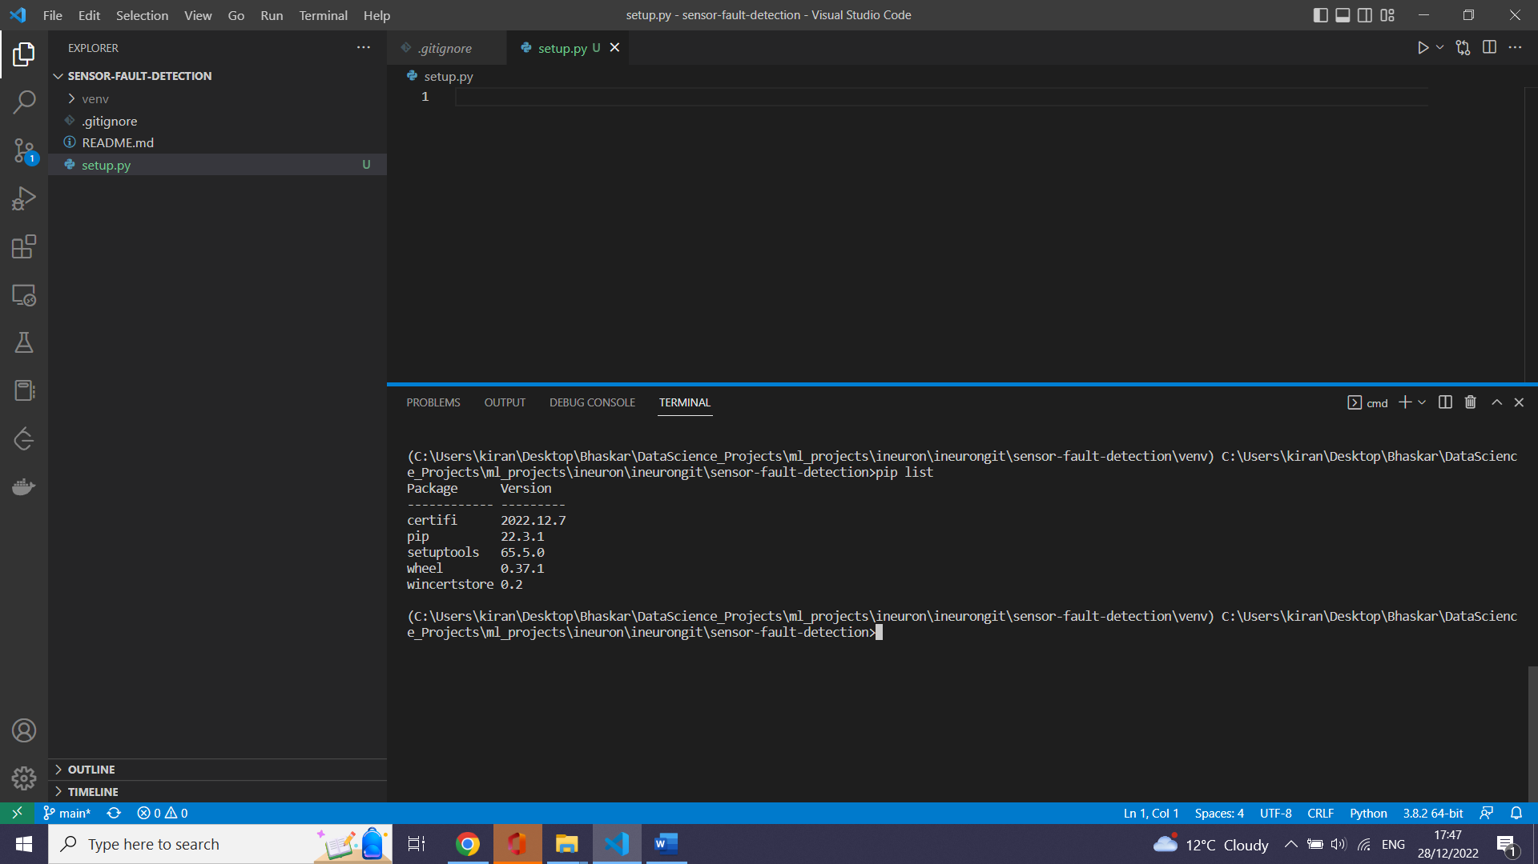

--create a sensor package._init__.py will make the folder a python package

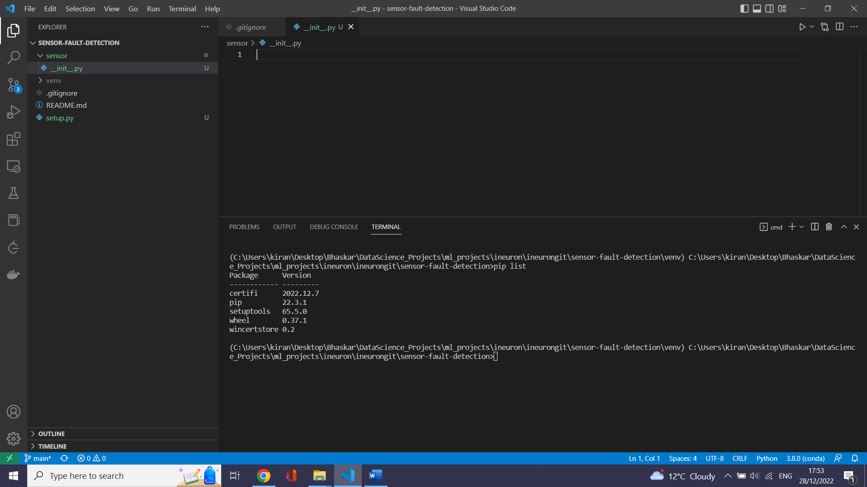

This is website where we find any python library . Any thing we do pip is installed from pypi.org

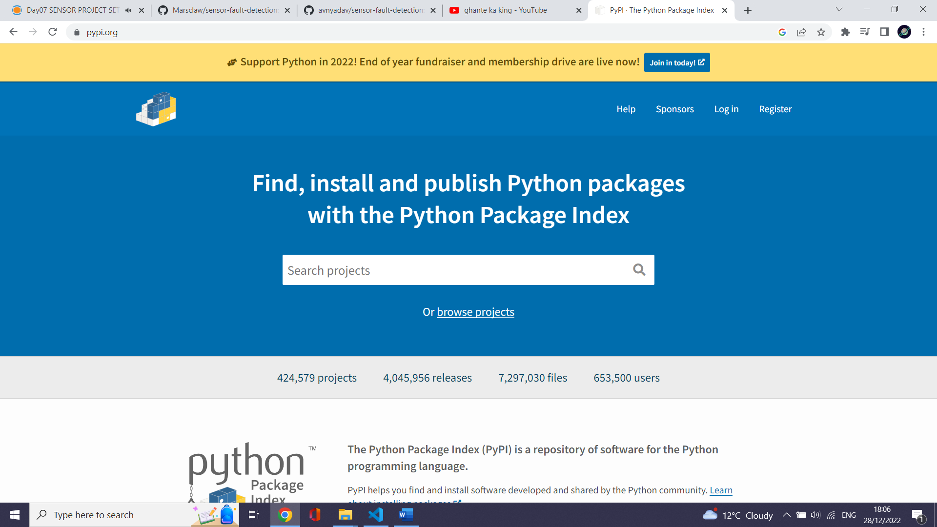

# configure setup.py (This is used foe building libraries)

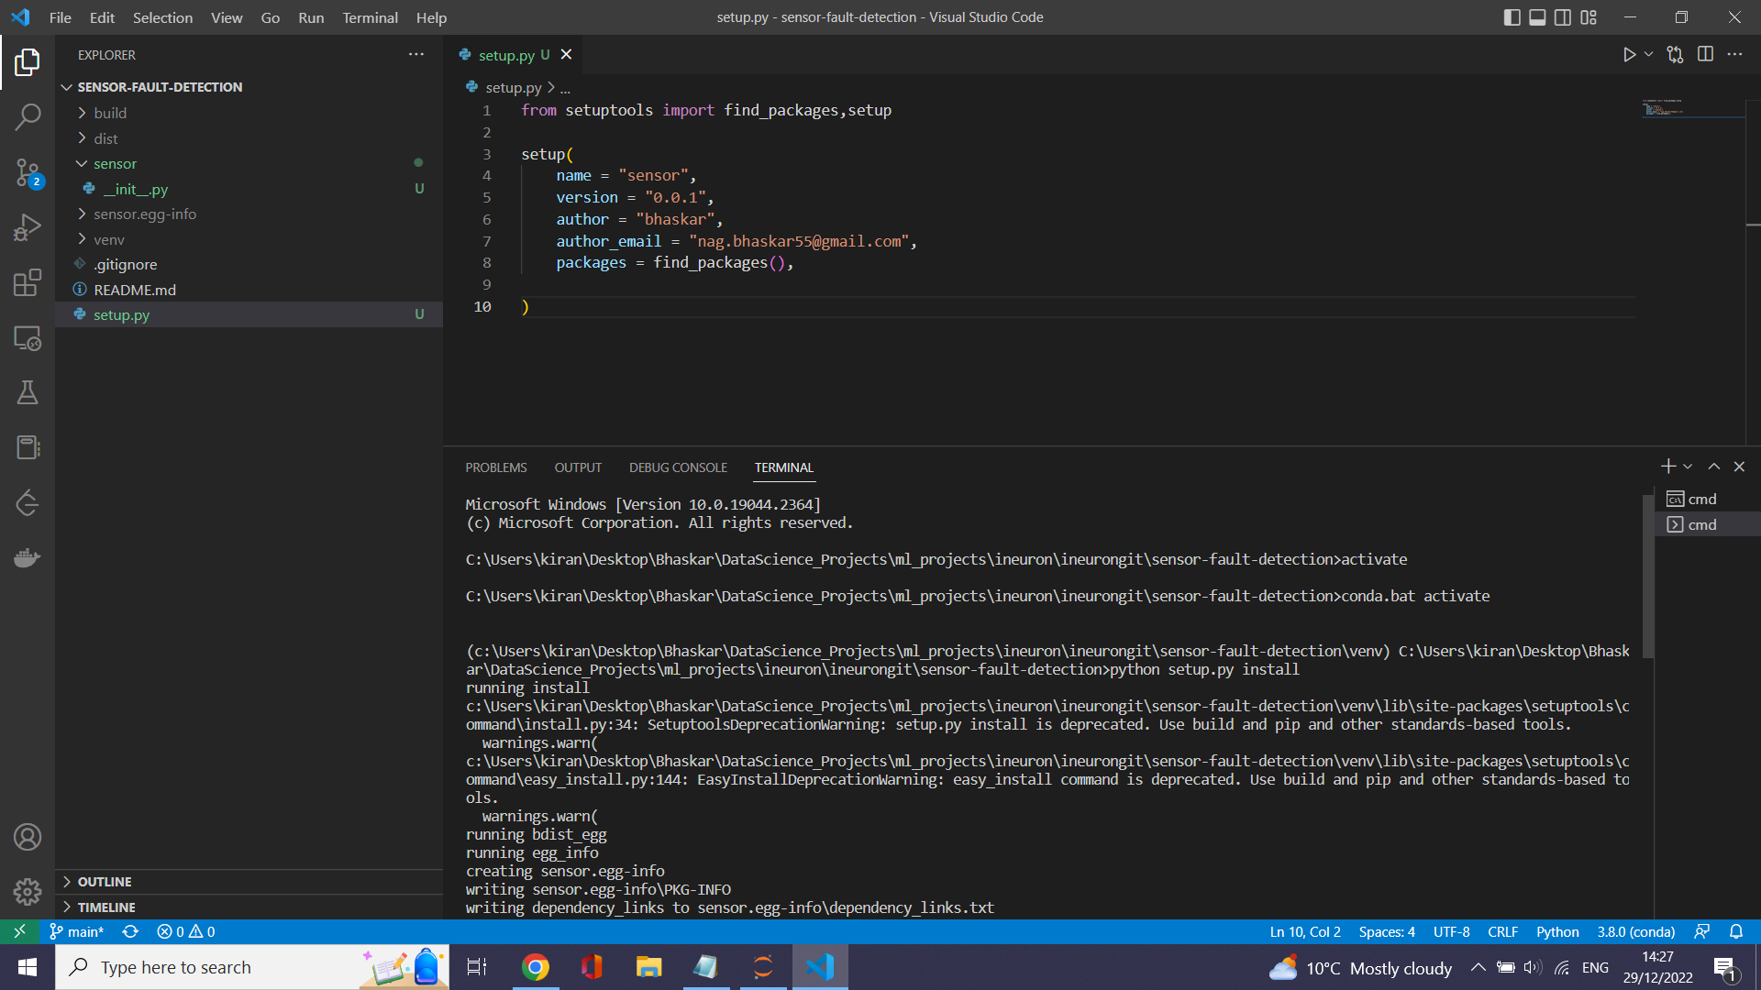

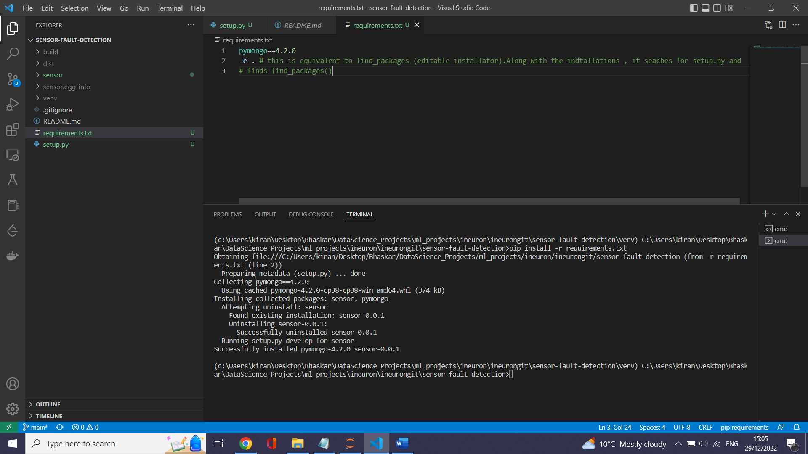

# create a folder package pipeline inside sensor package

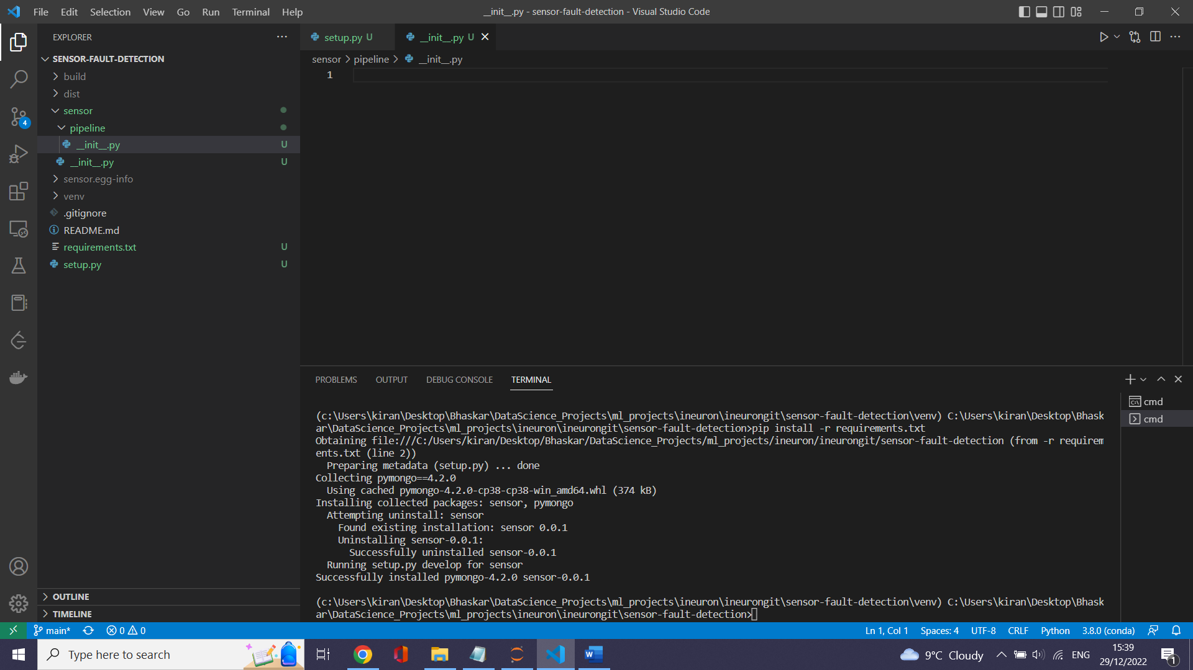

# create components package inside sensor package.We build a components individually inside component package .We join them in pipeline package

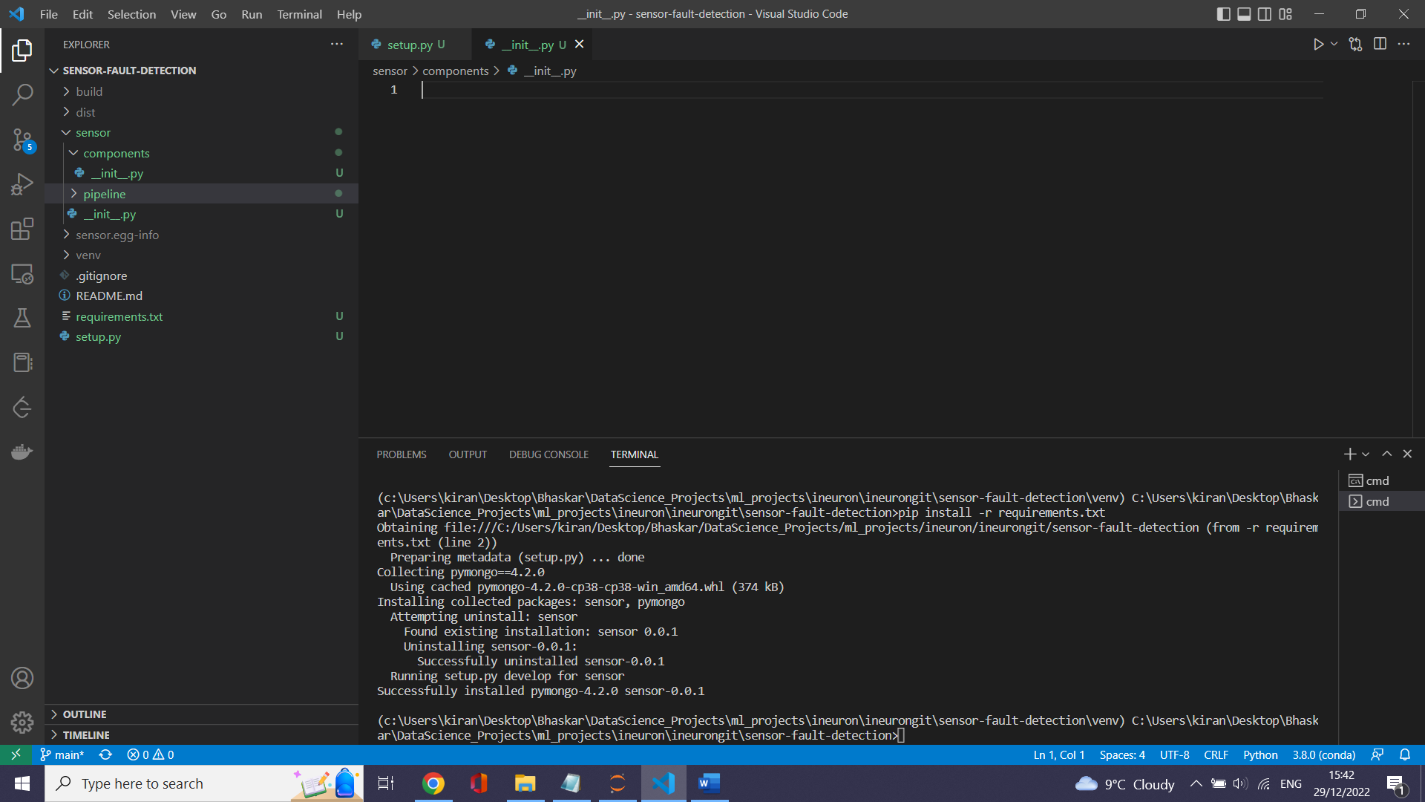

# create data_Access folder which has configurations of mongo DB and mechanism to retrieve data from DB

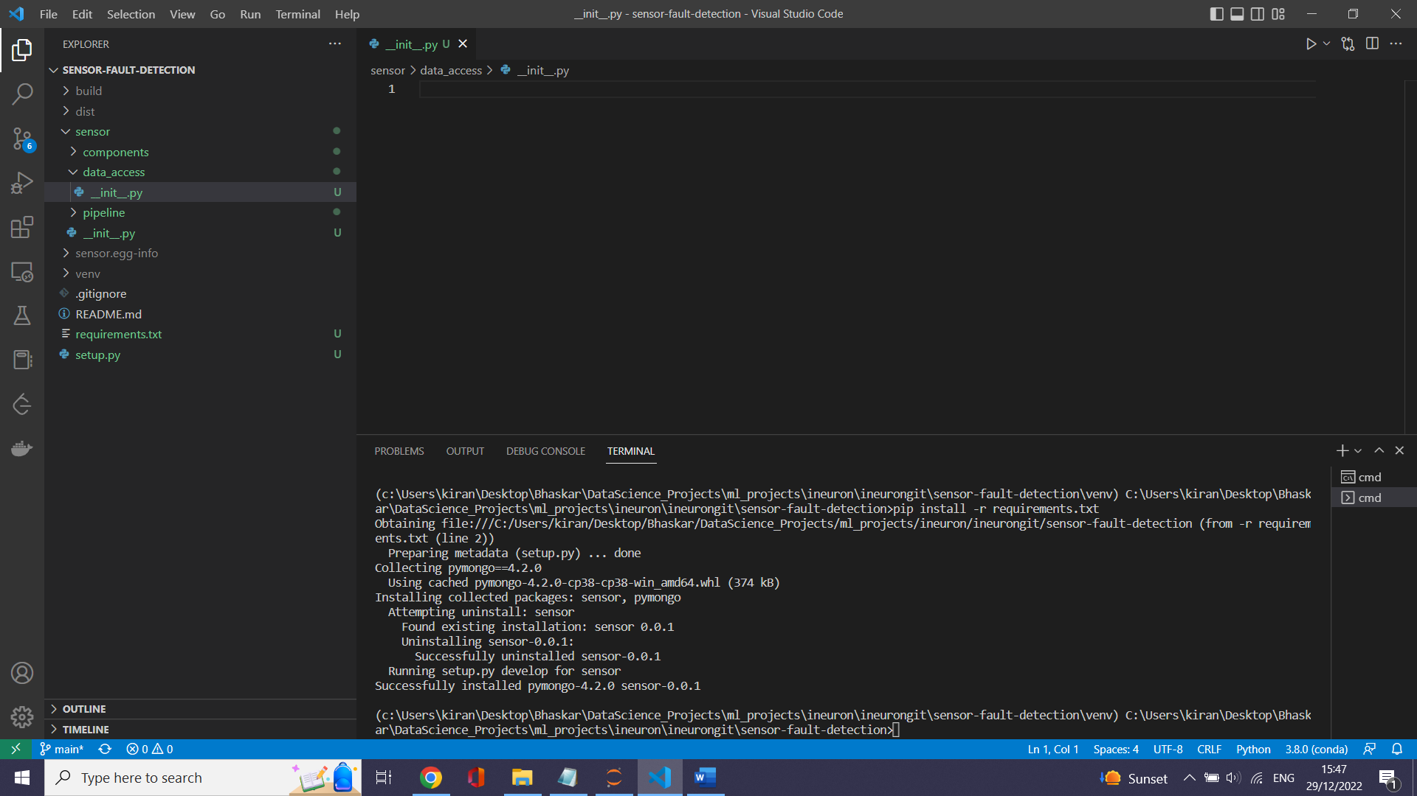

# we are using s3 bucket .All those things related to AWS are written in cloud storage package which we create in sensor folder

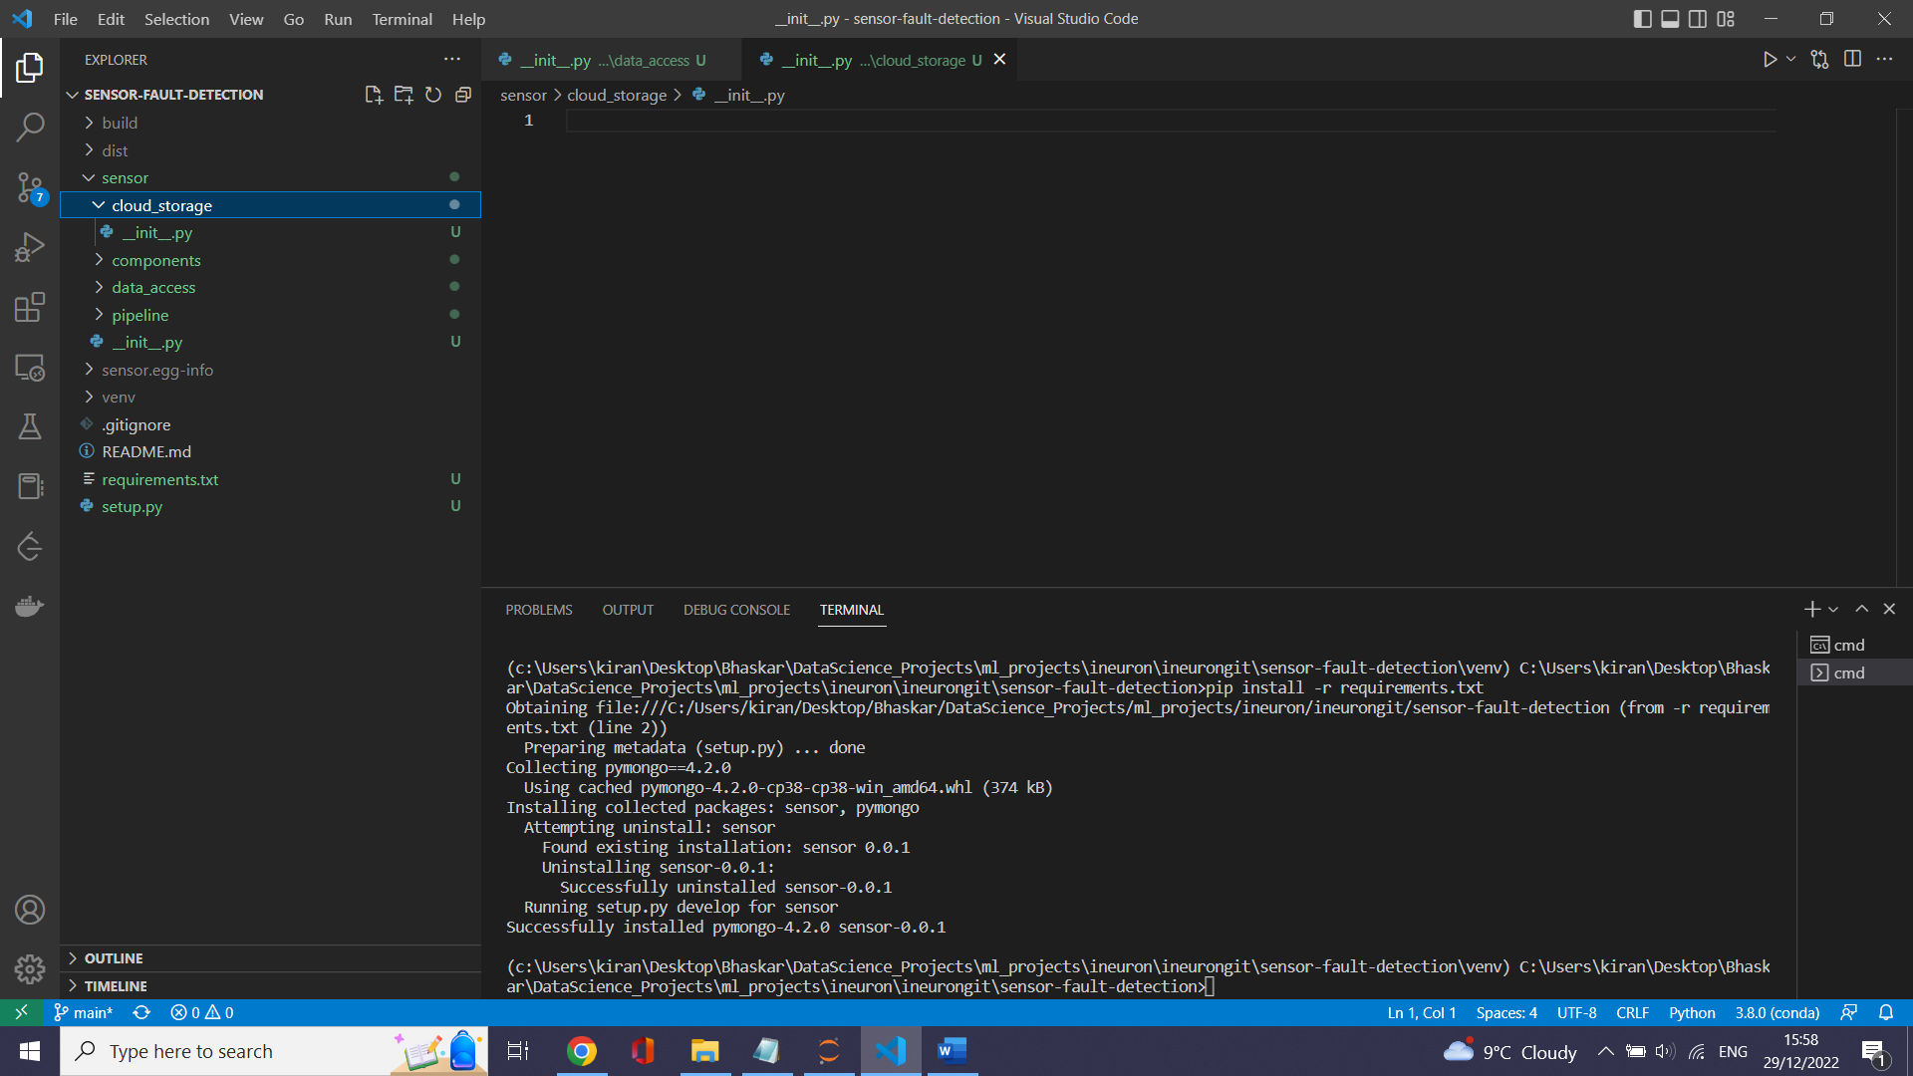

# create configuration package which handles connections to cloud , Database etc

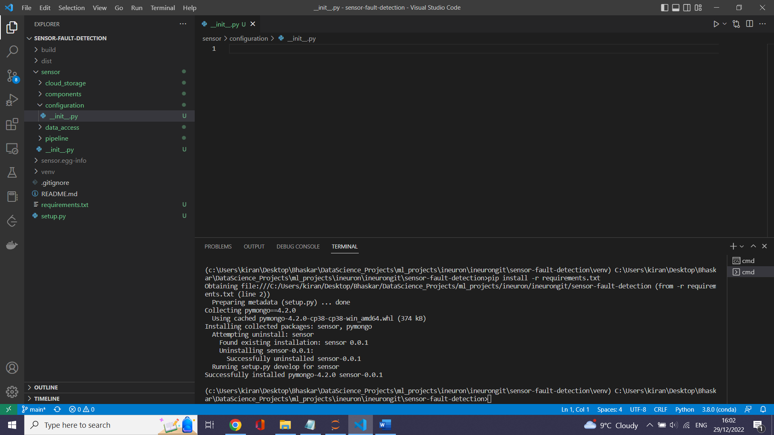

# Create constant package which handles constants

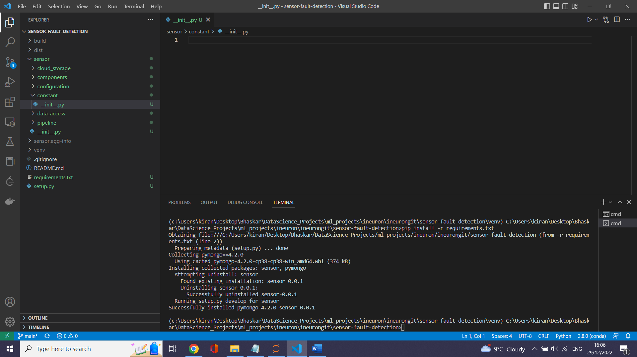

# logger.py

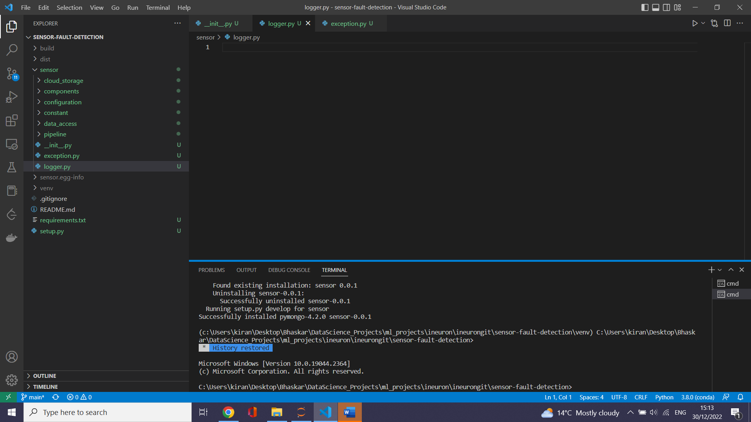

# exception.py

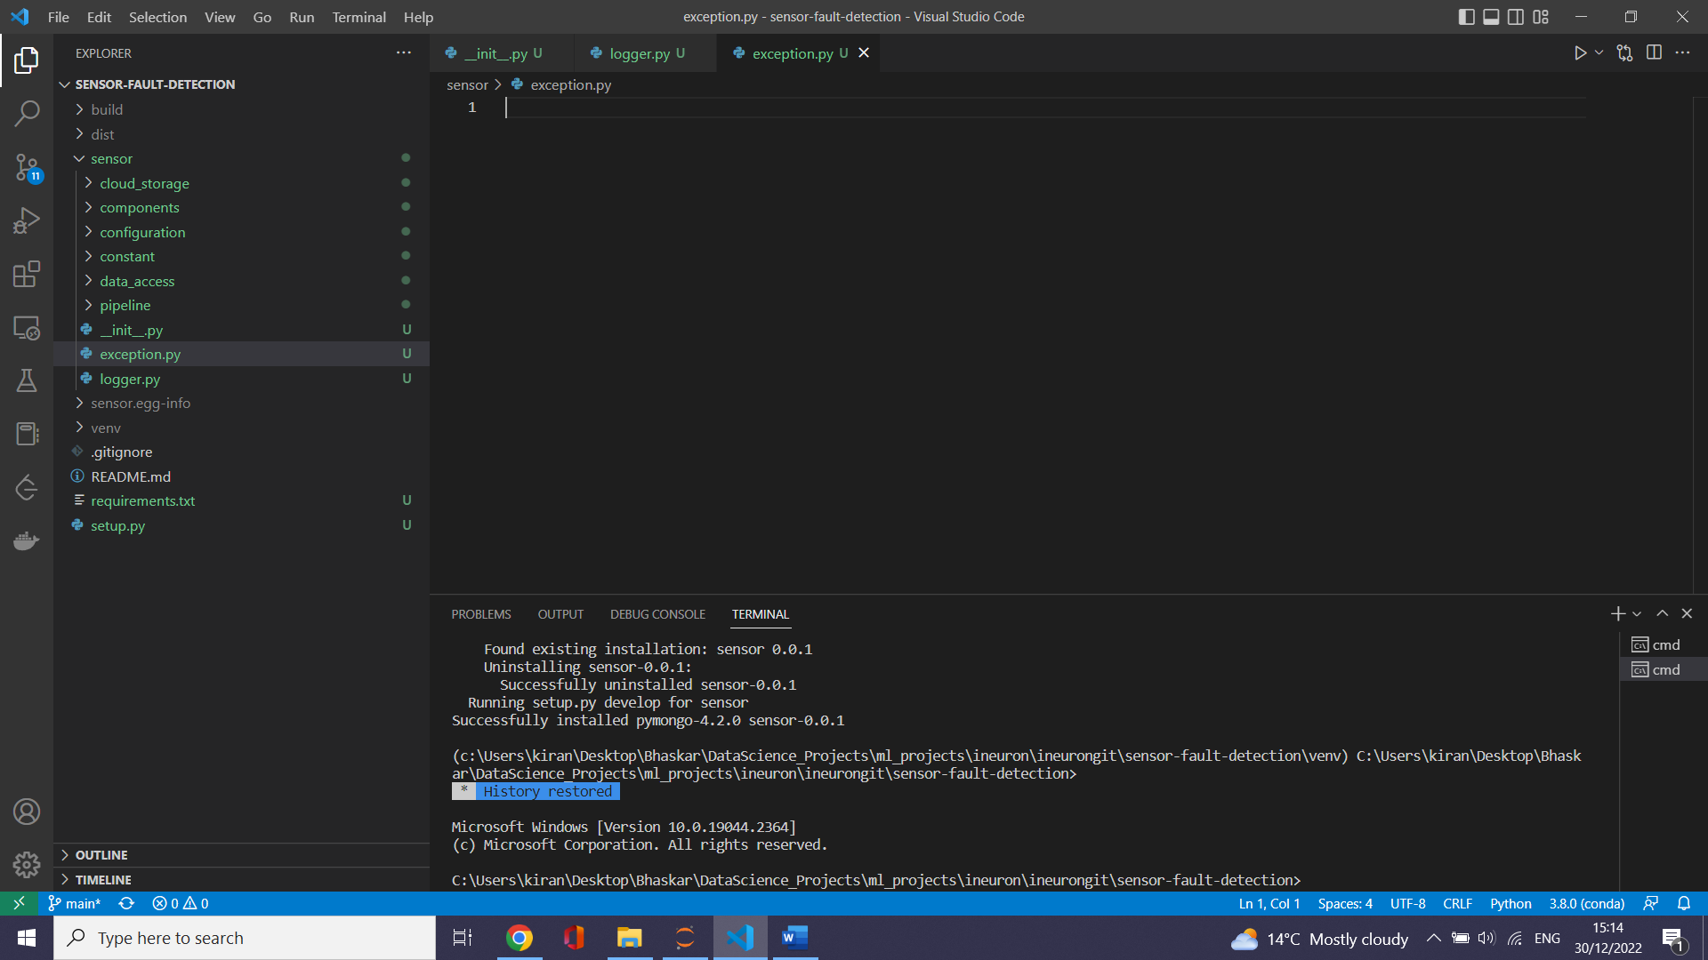

# Structure of real time ML project taken from Google mlops

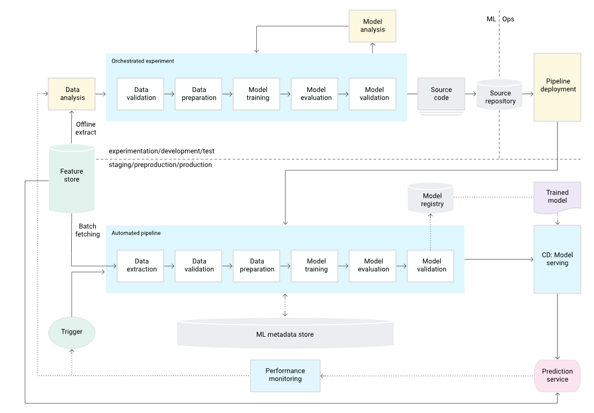

Feature store -----> Mongo DB

# create Entity folder to determine the structure of input-output of every component .Eg input would be whether csv /int etc

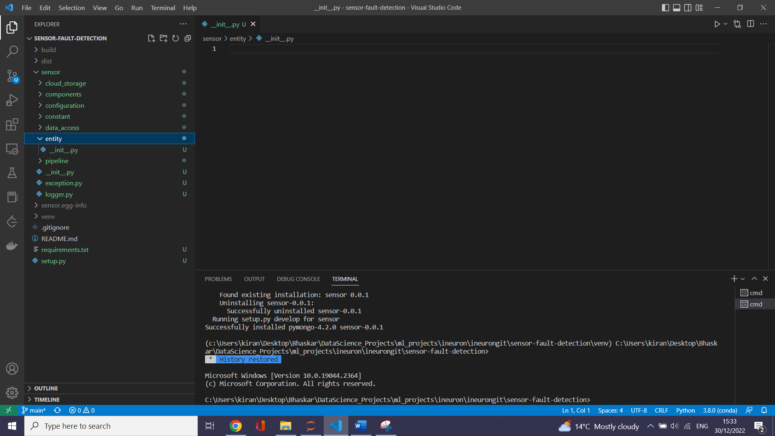

# An **artifact** is a **machine learning** term that is used to describe the output created by the training process. Output could be a fully trained model, a model checkpoint, or a file created during the training process.

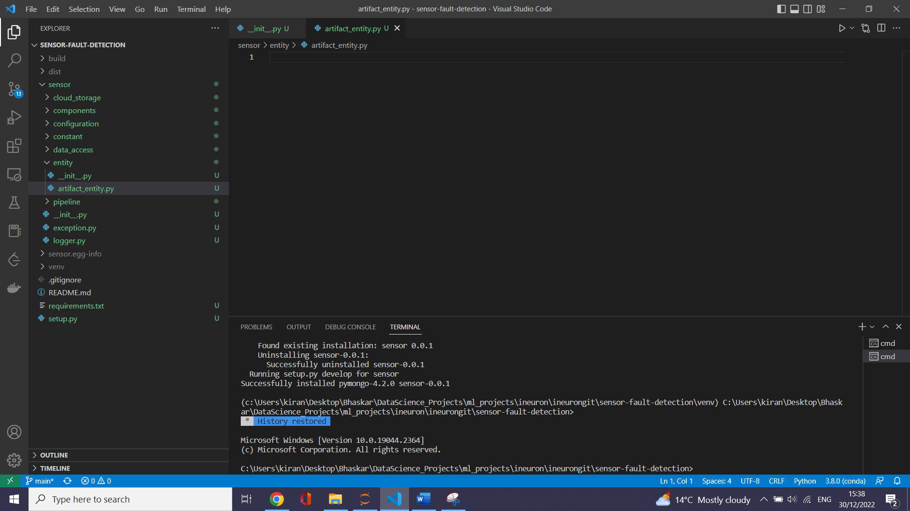

# create config_entity .py which specifies configuration for each entity

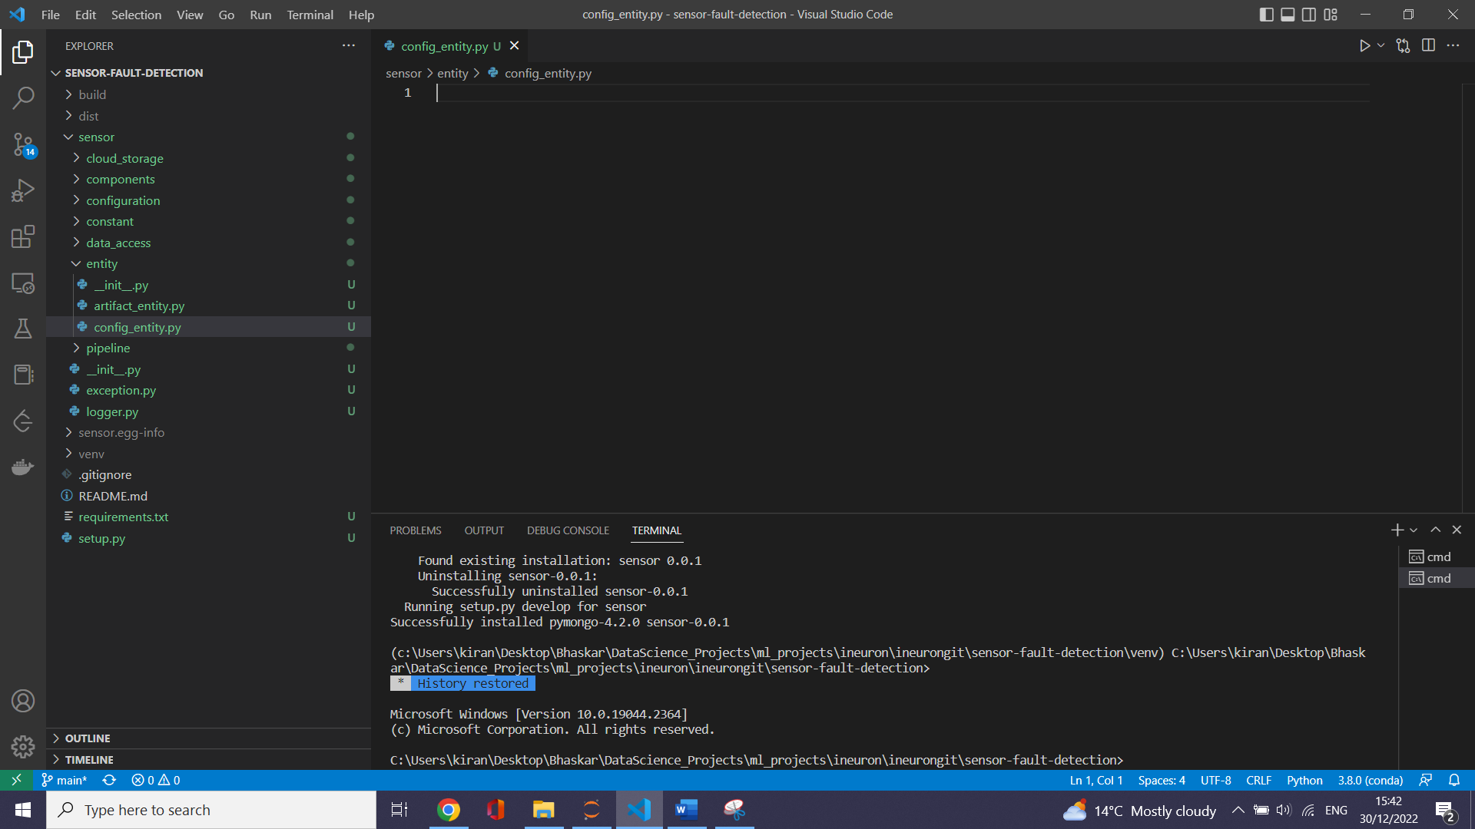

# in real time project we need to do our own custom code /project etc in ML .So we create ml folder

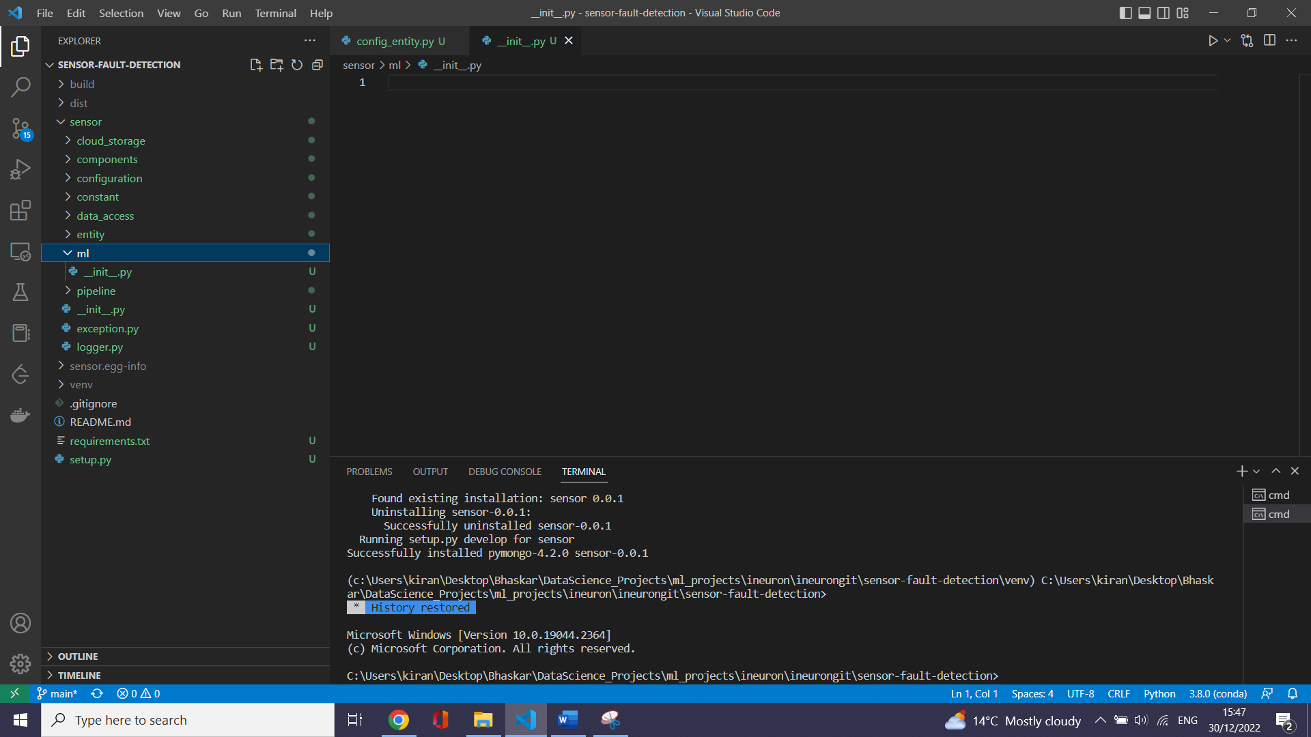

Green colour in the left like sensor ,requirements.txt etc part is that which are tracked out by GIT

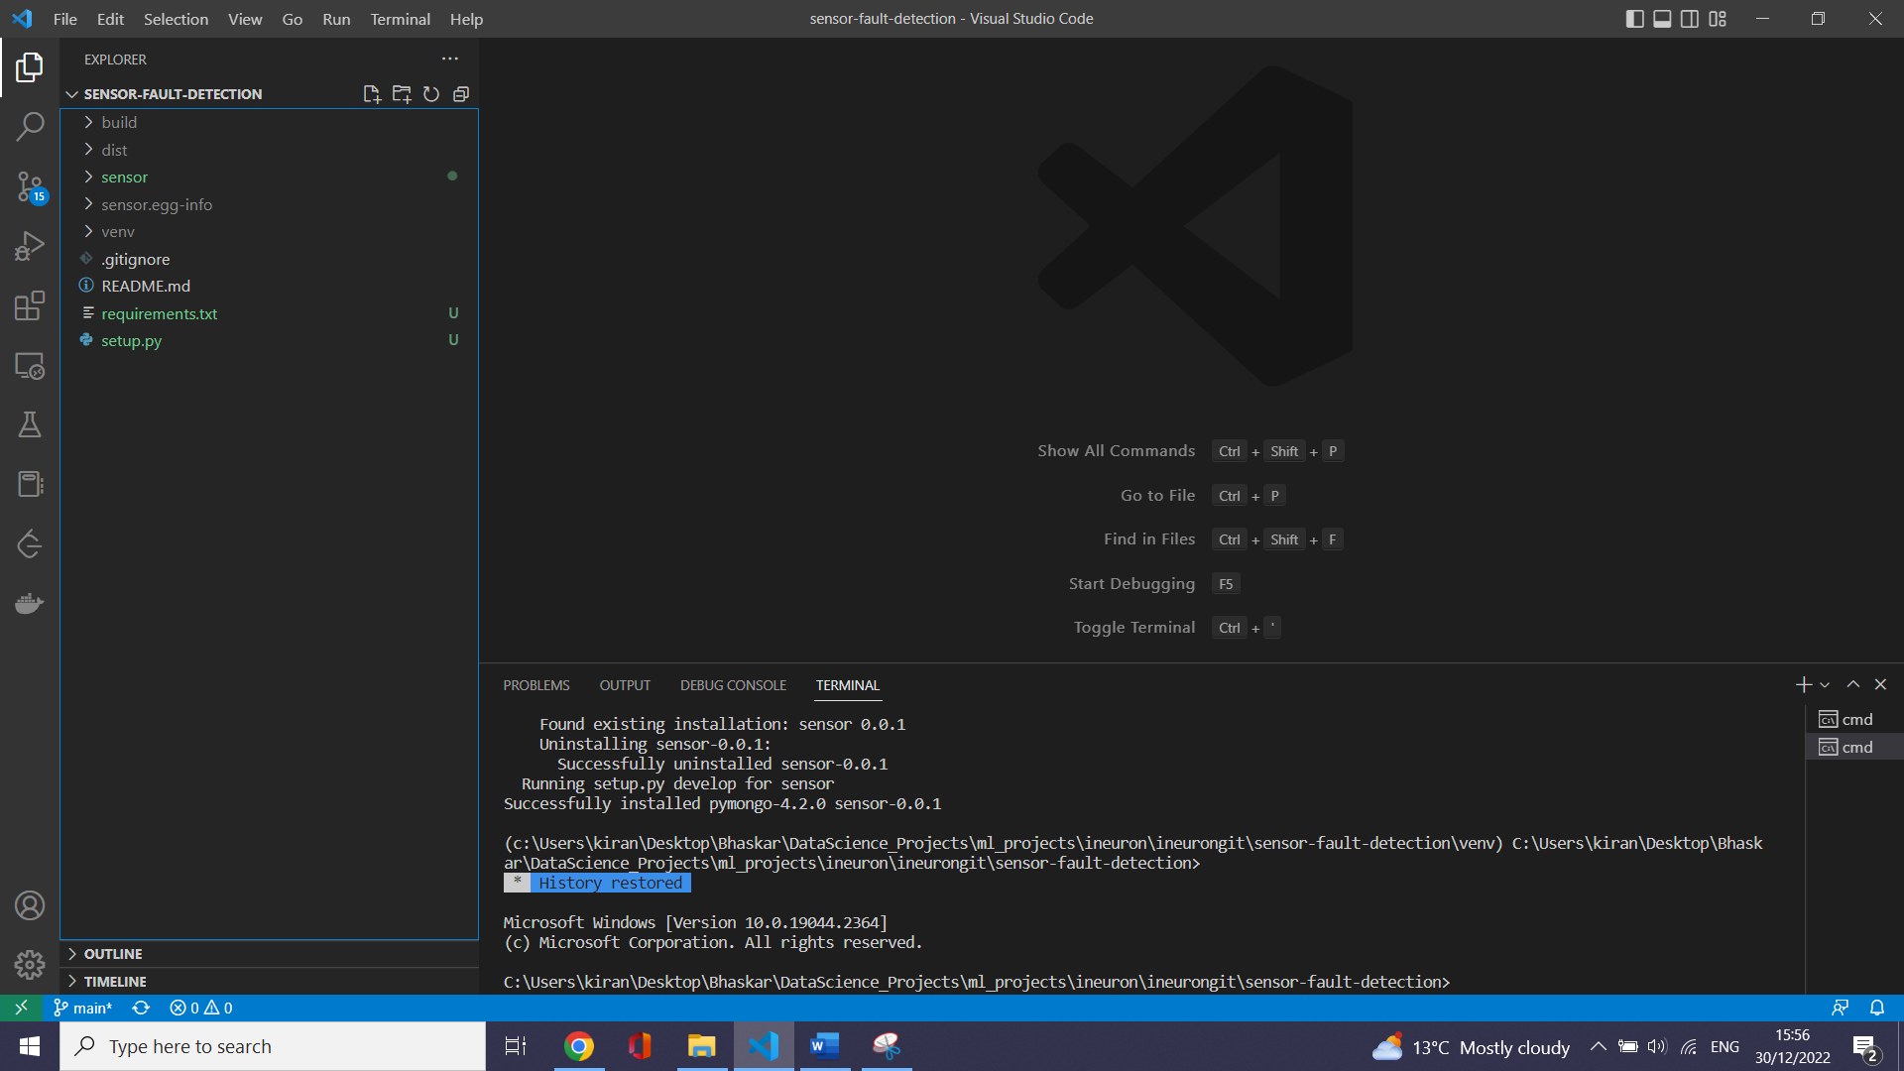

# How to connect to Mongo Db

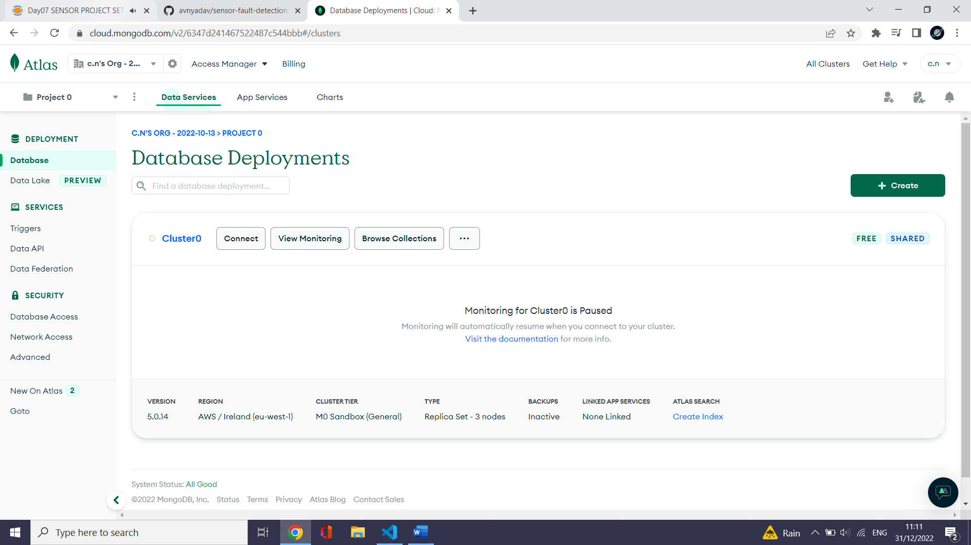

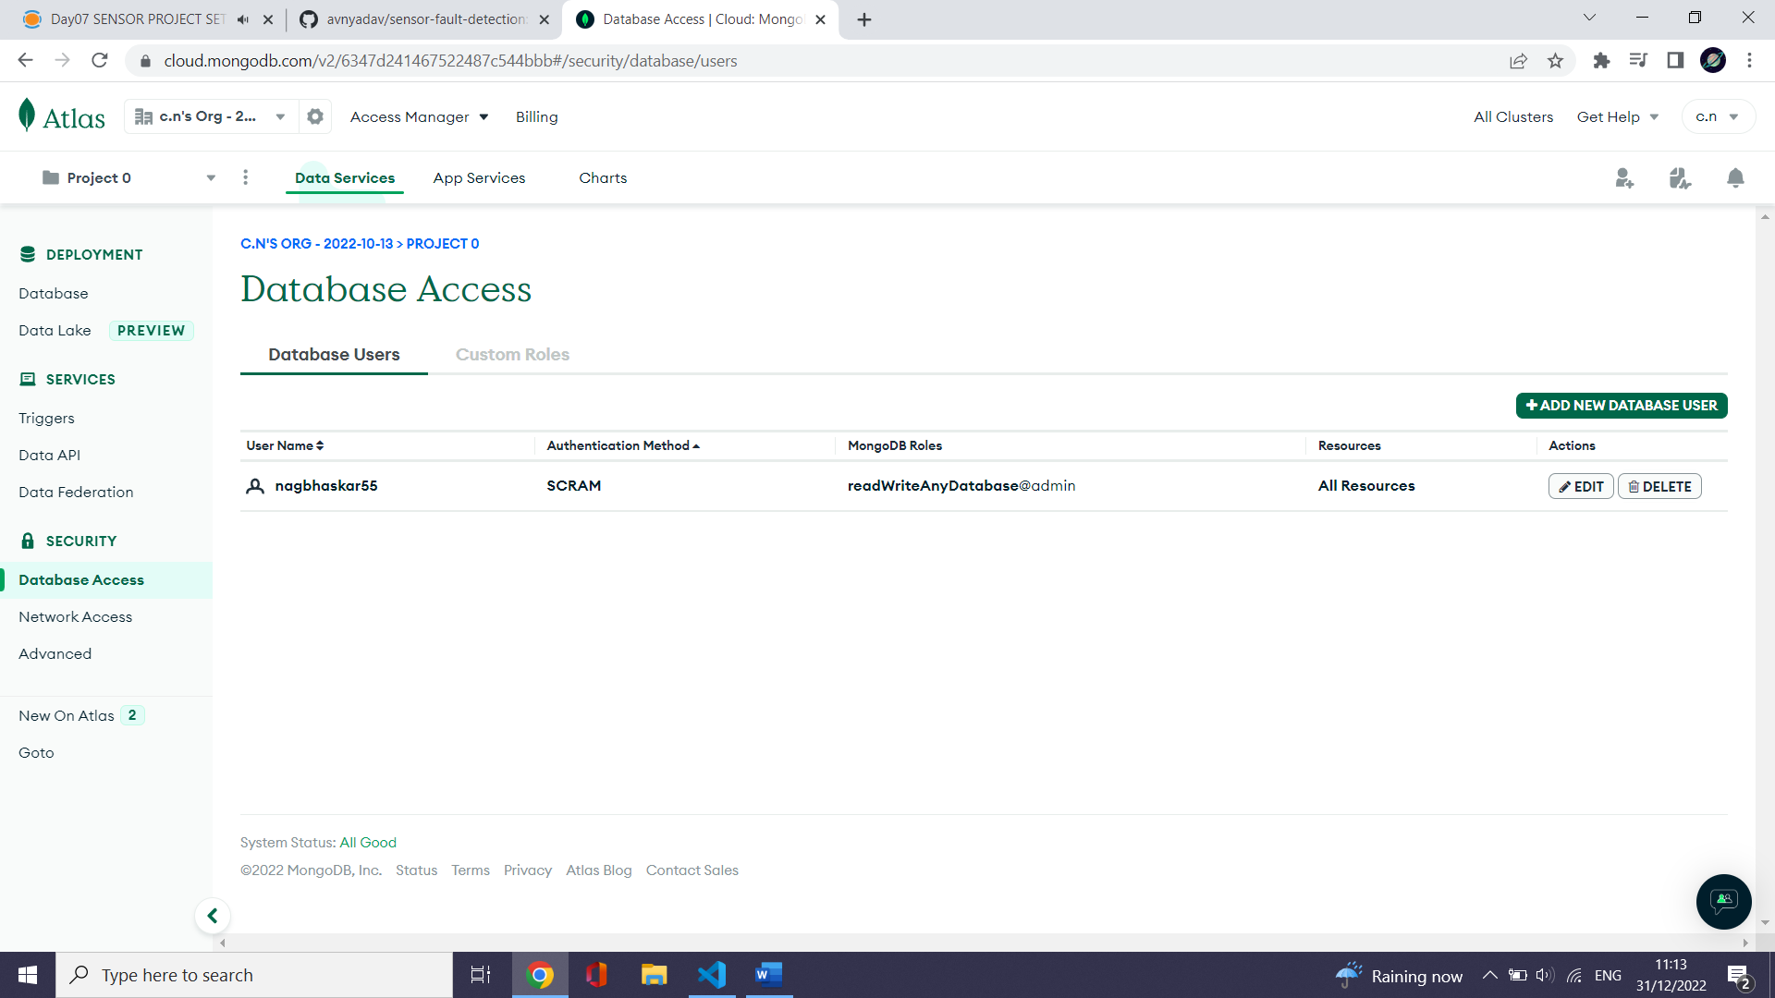

* + 1. mena tht u can connect to any IP

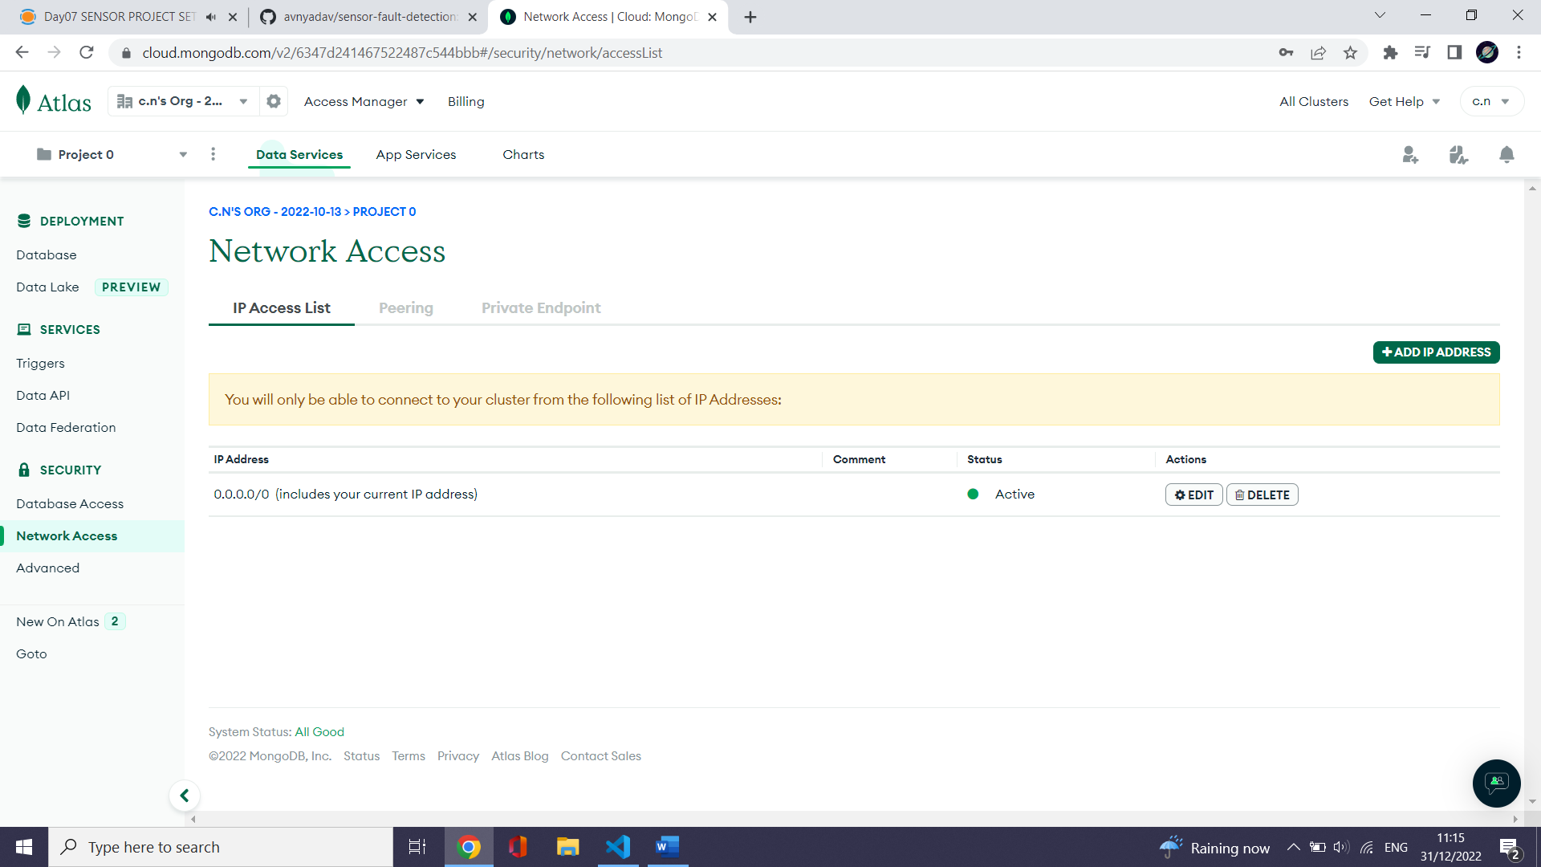

# Find MongoDB URL

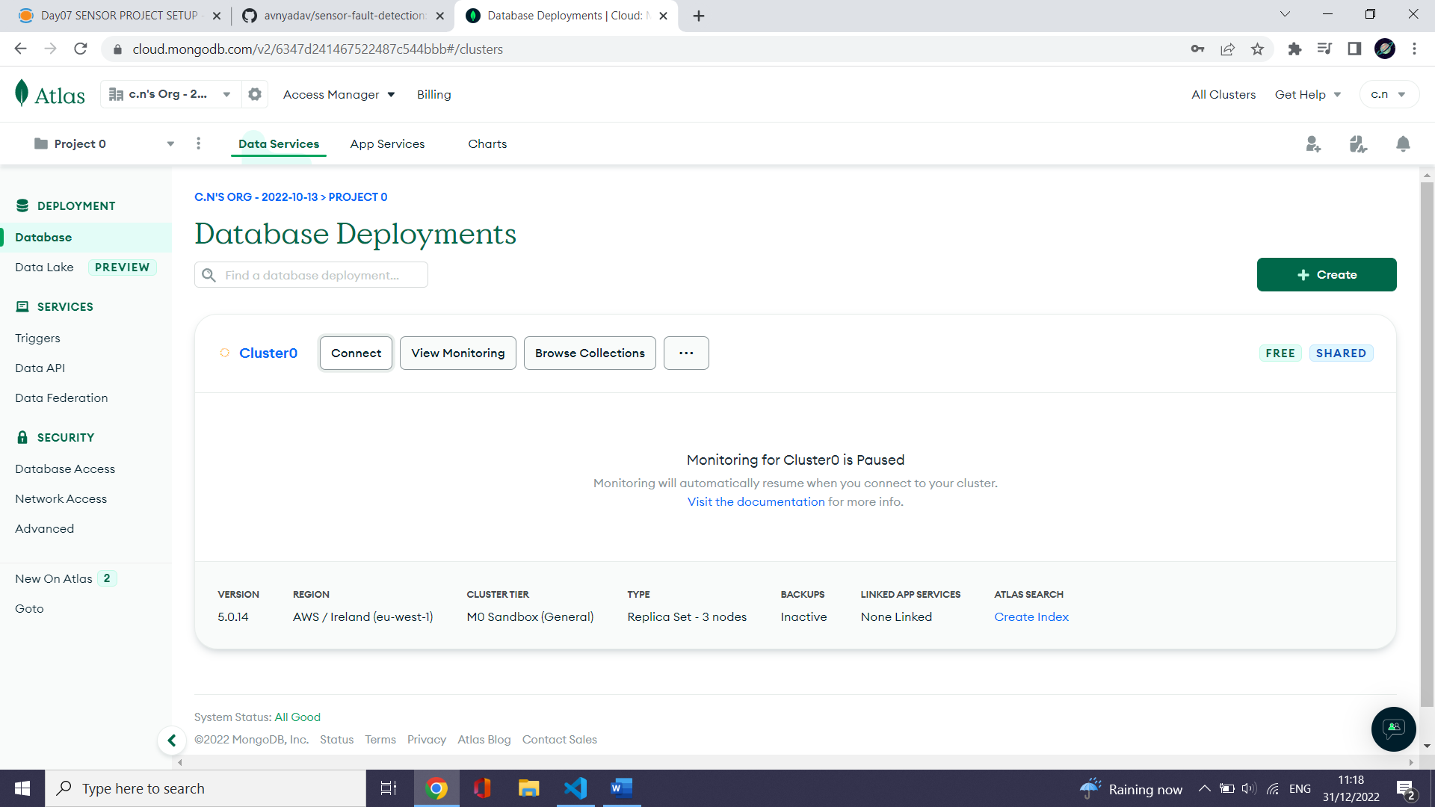

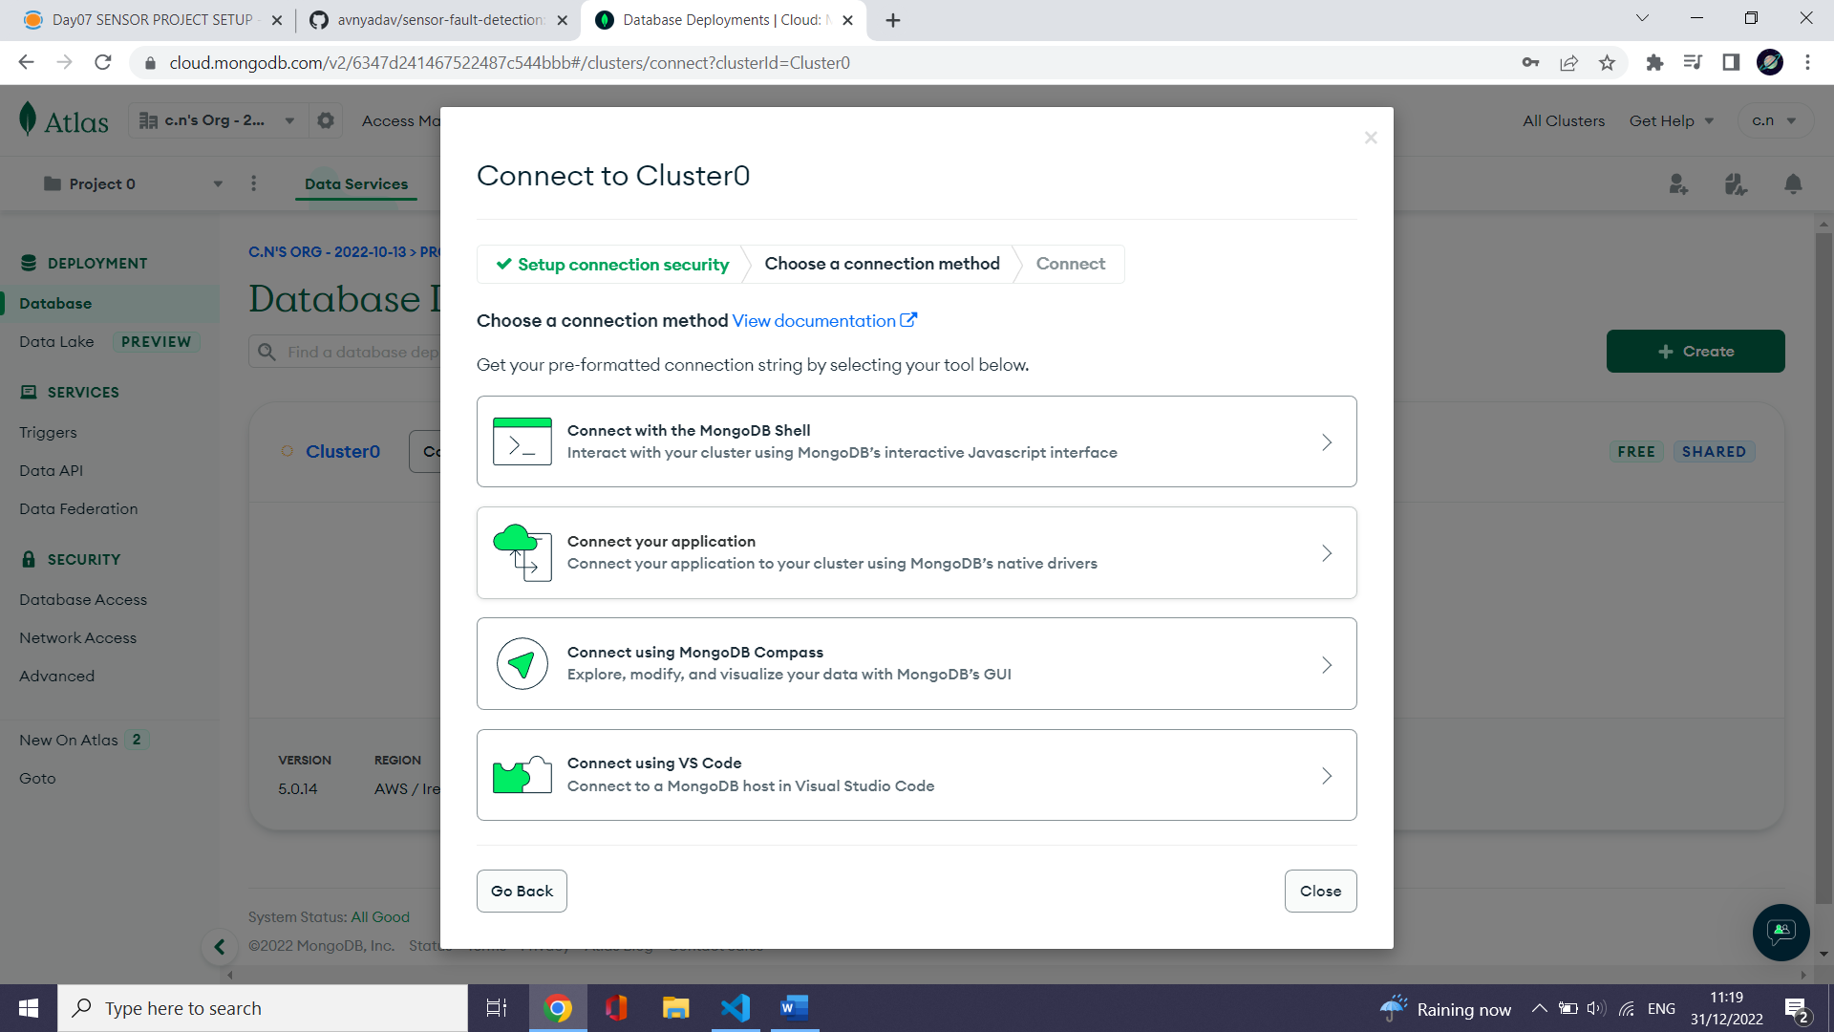

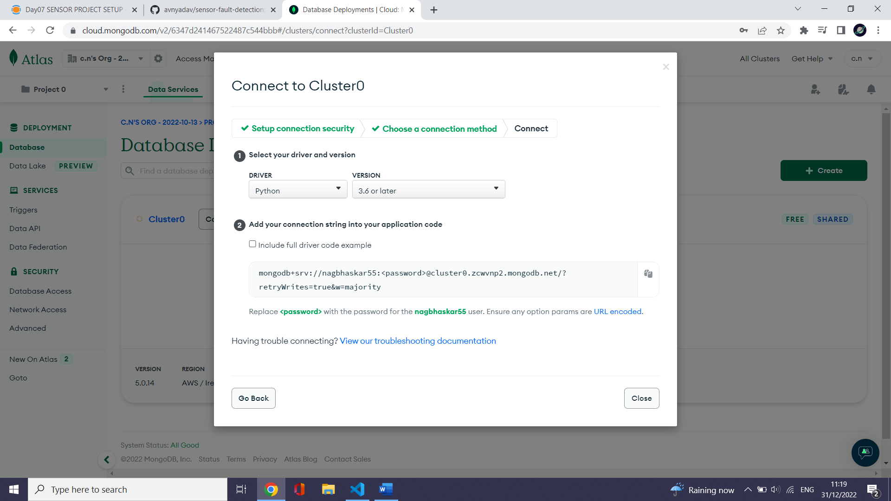

# Mongo DB URL

mongodb+srv://nagbhaskar55:<password>@cluster0.zcwvnp2.mongodb.net/?retryWrites=true&w=majority

# Open MongoDB compass

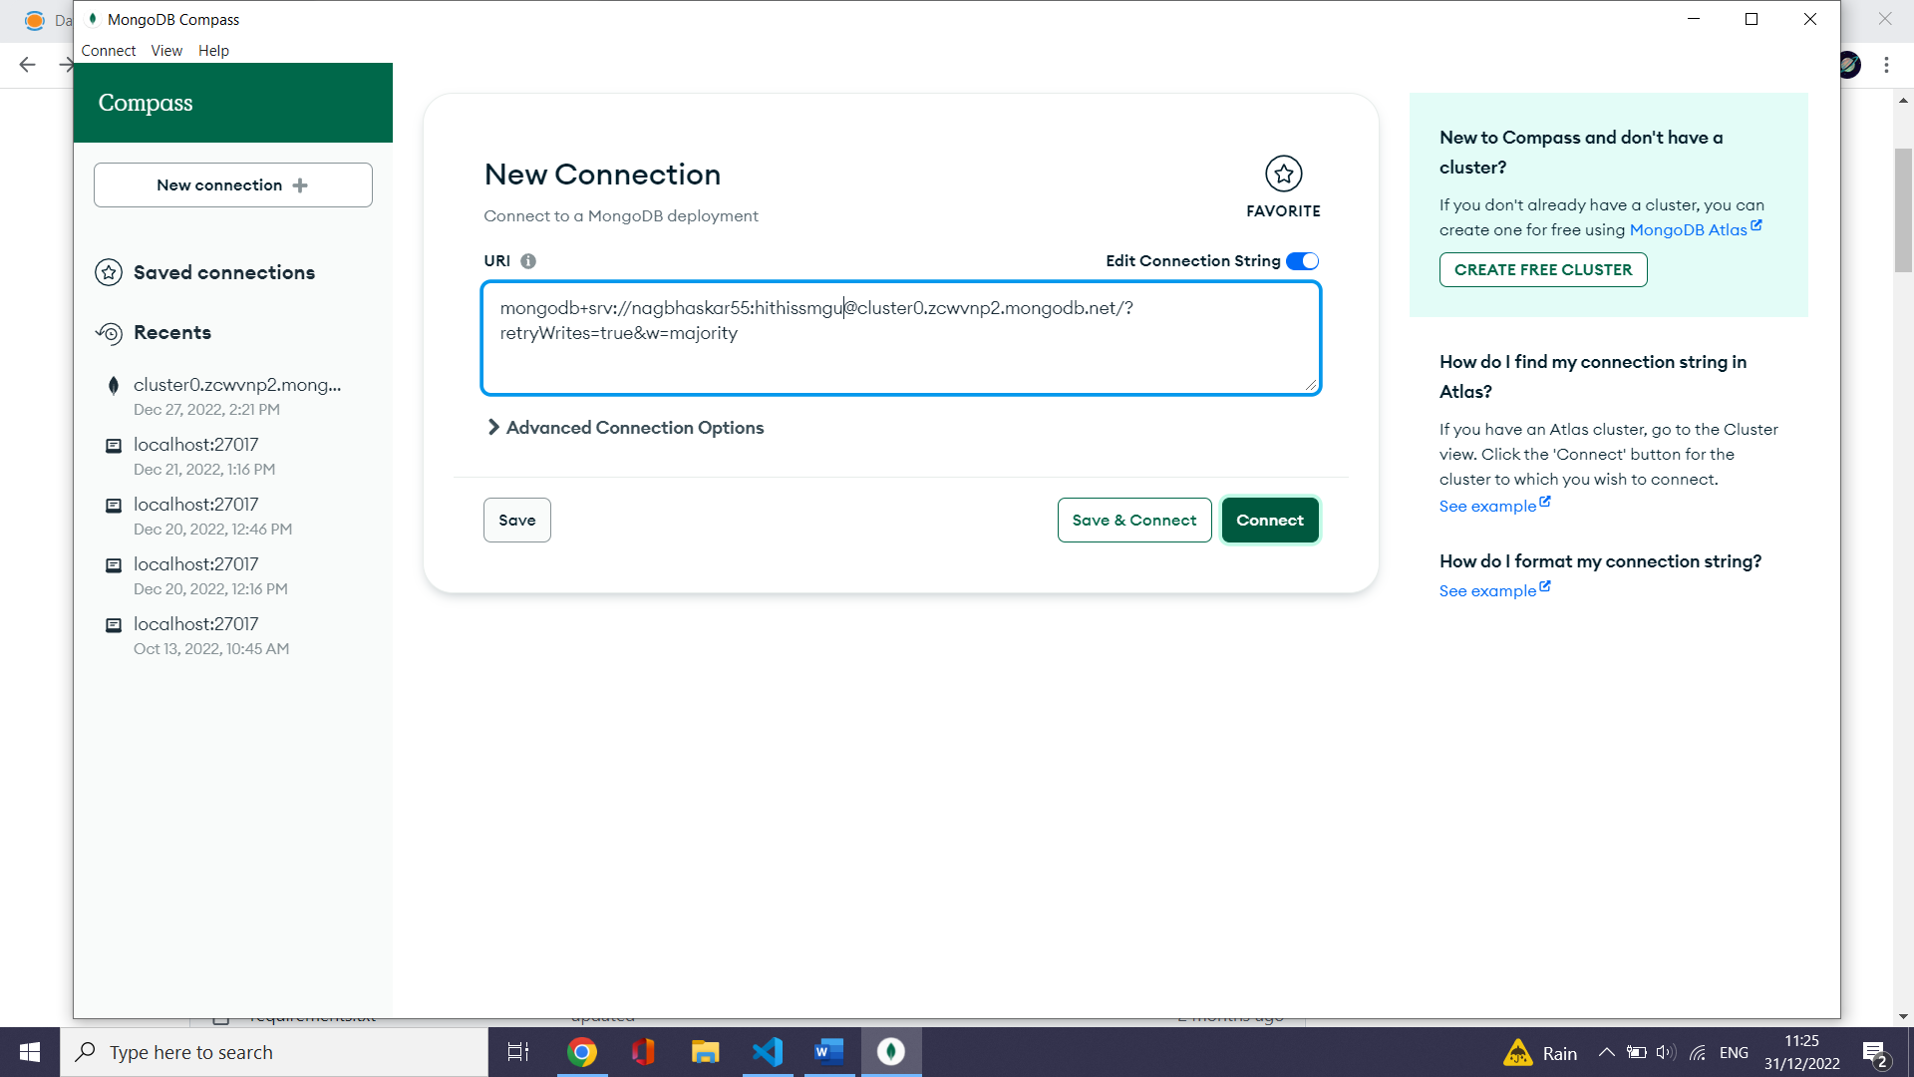

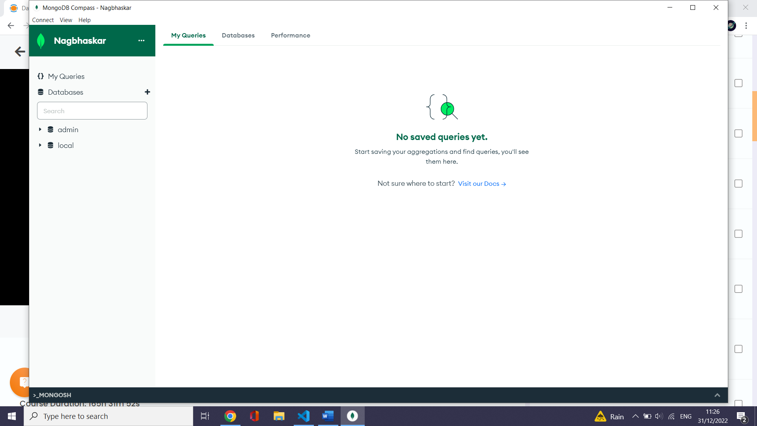

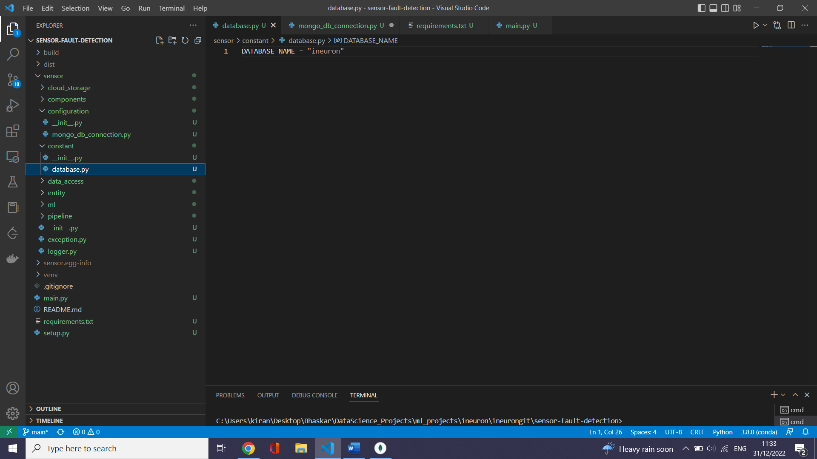

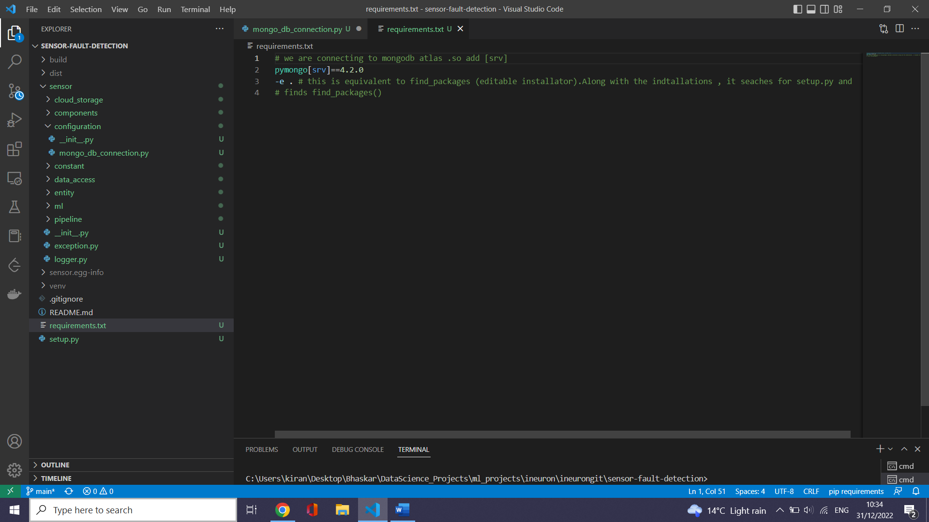

# define the mongodb configuration connections

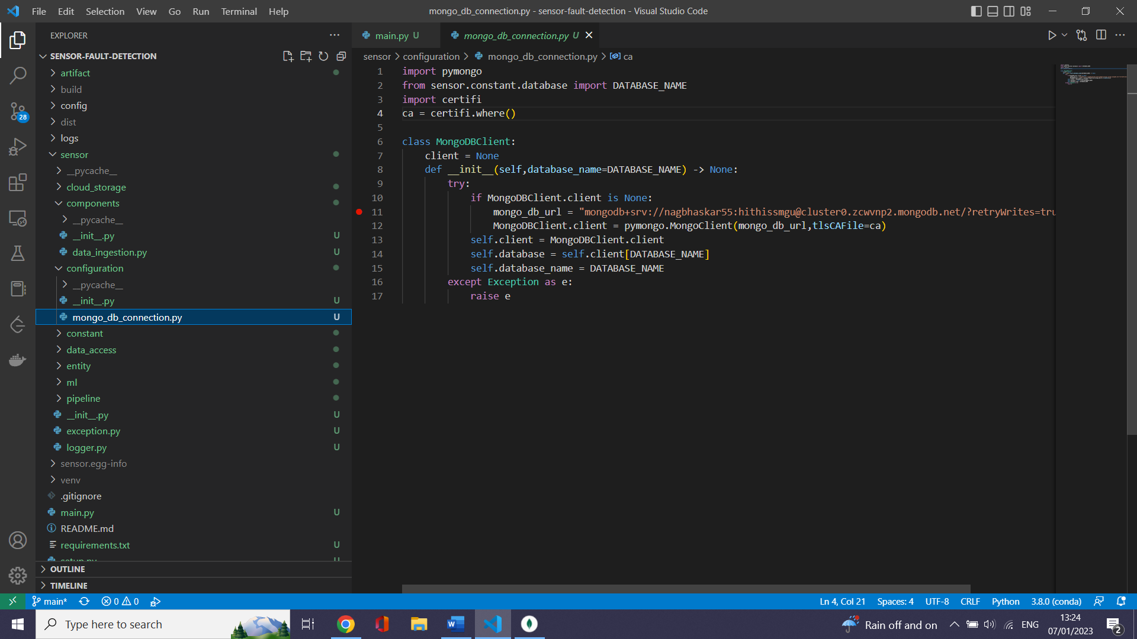

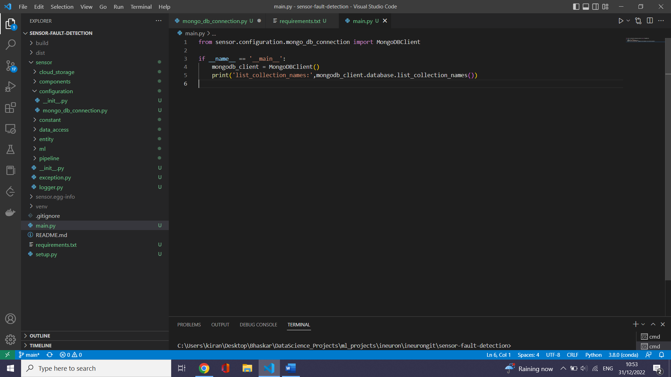

# Test if the DB connections are correct

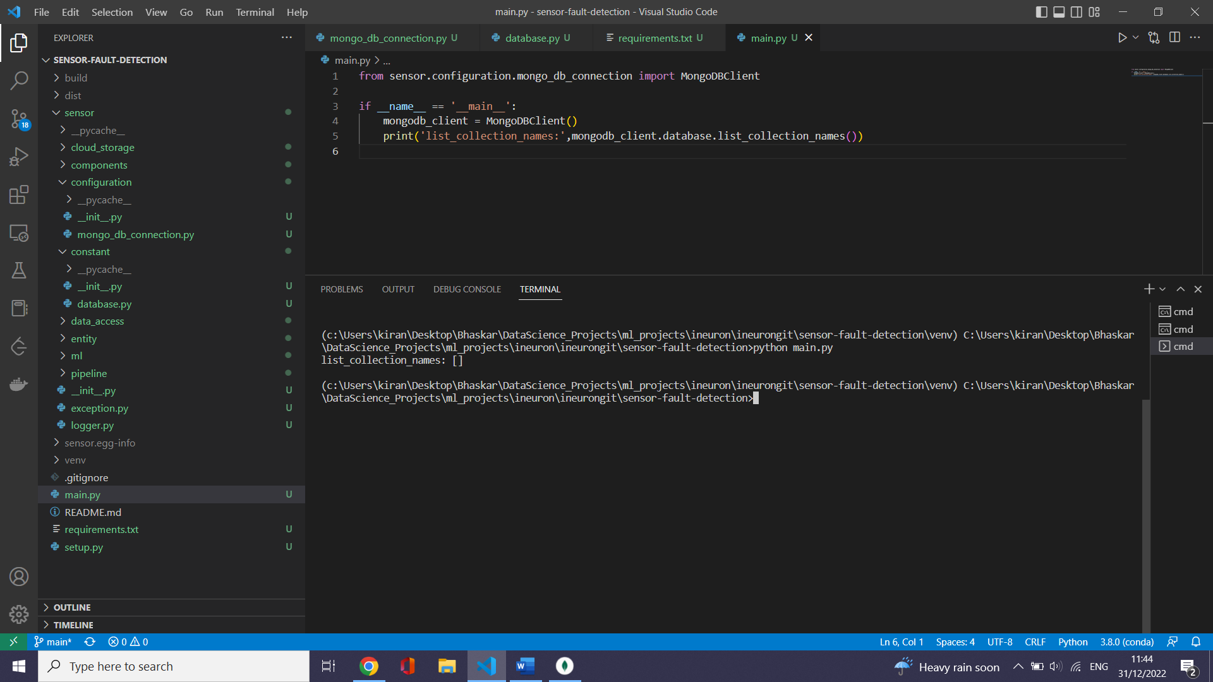

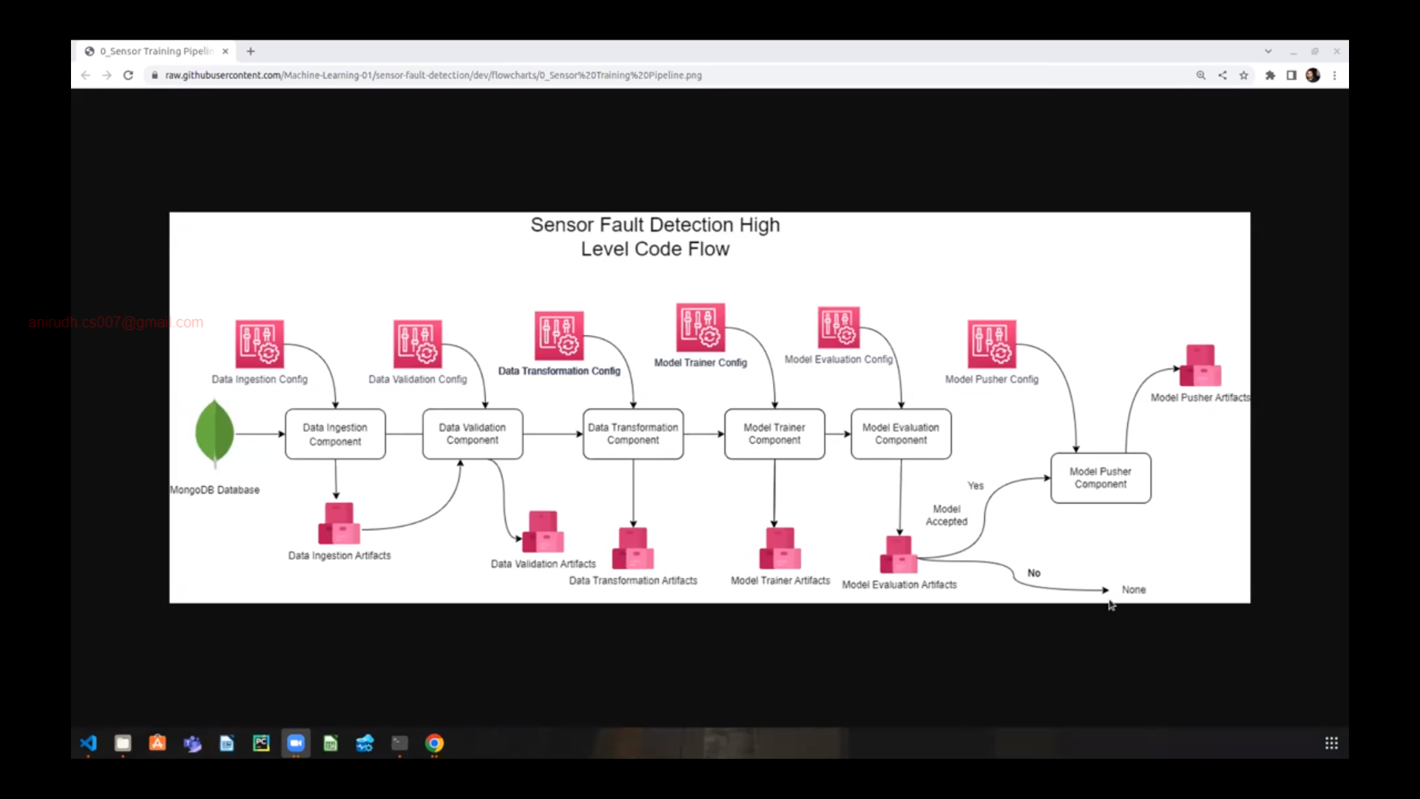

# Create a file to define environment variables

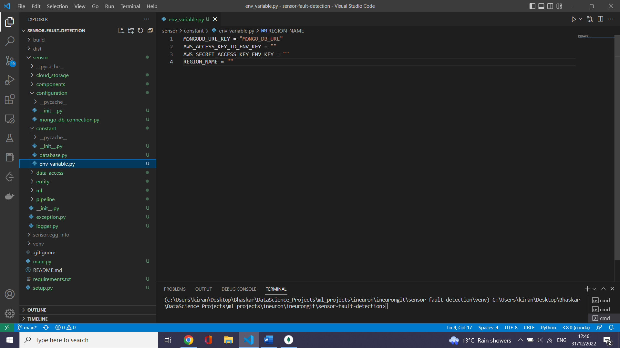

# Define exception.py (This will be common for all projects)

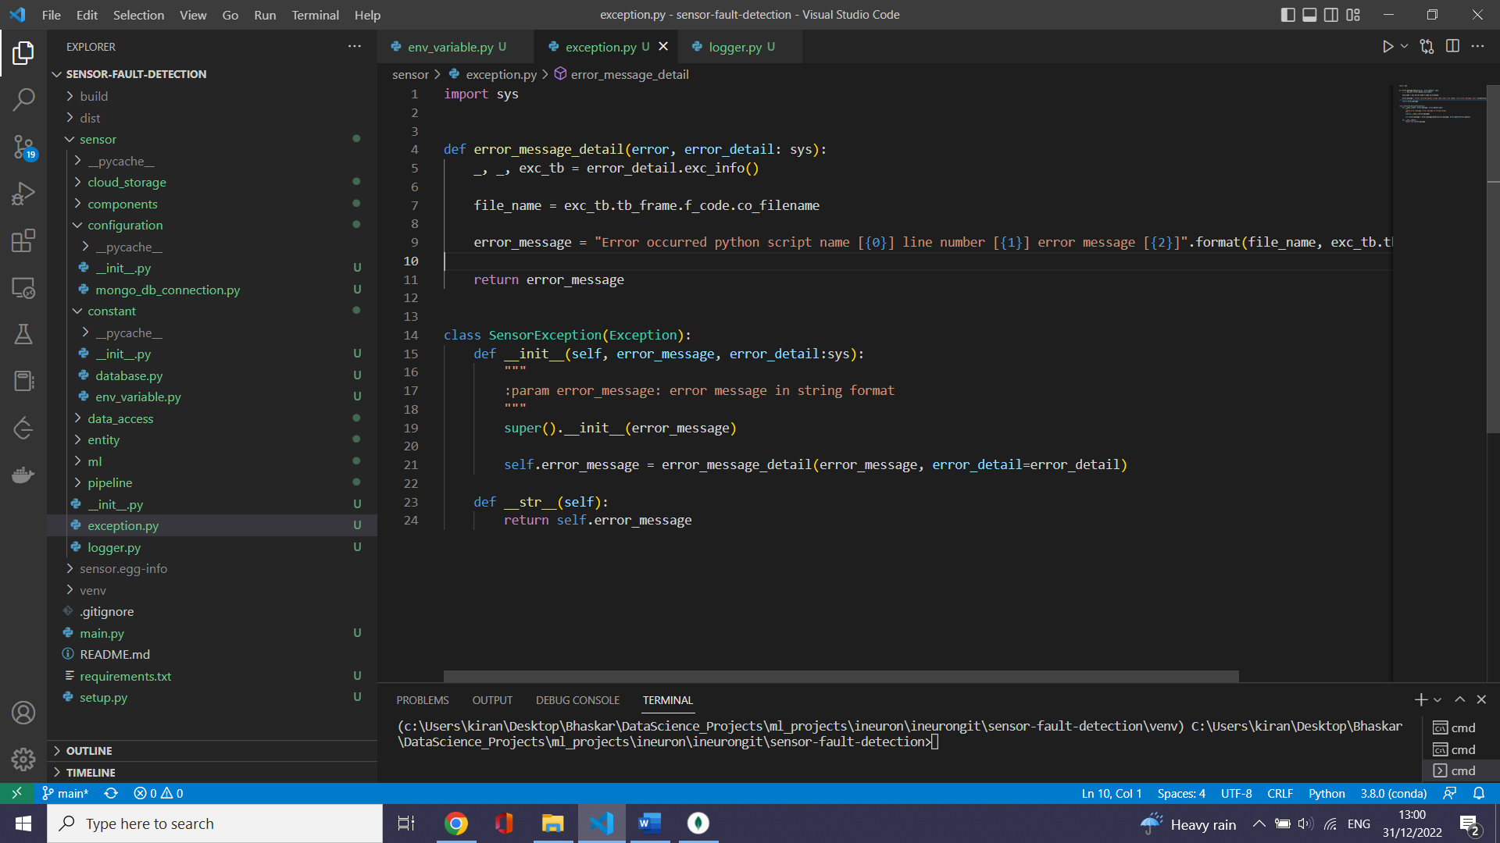

# Define logger.py (This will be common for all projects)

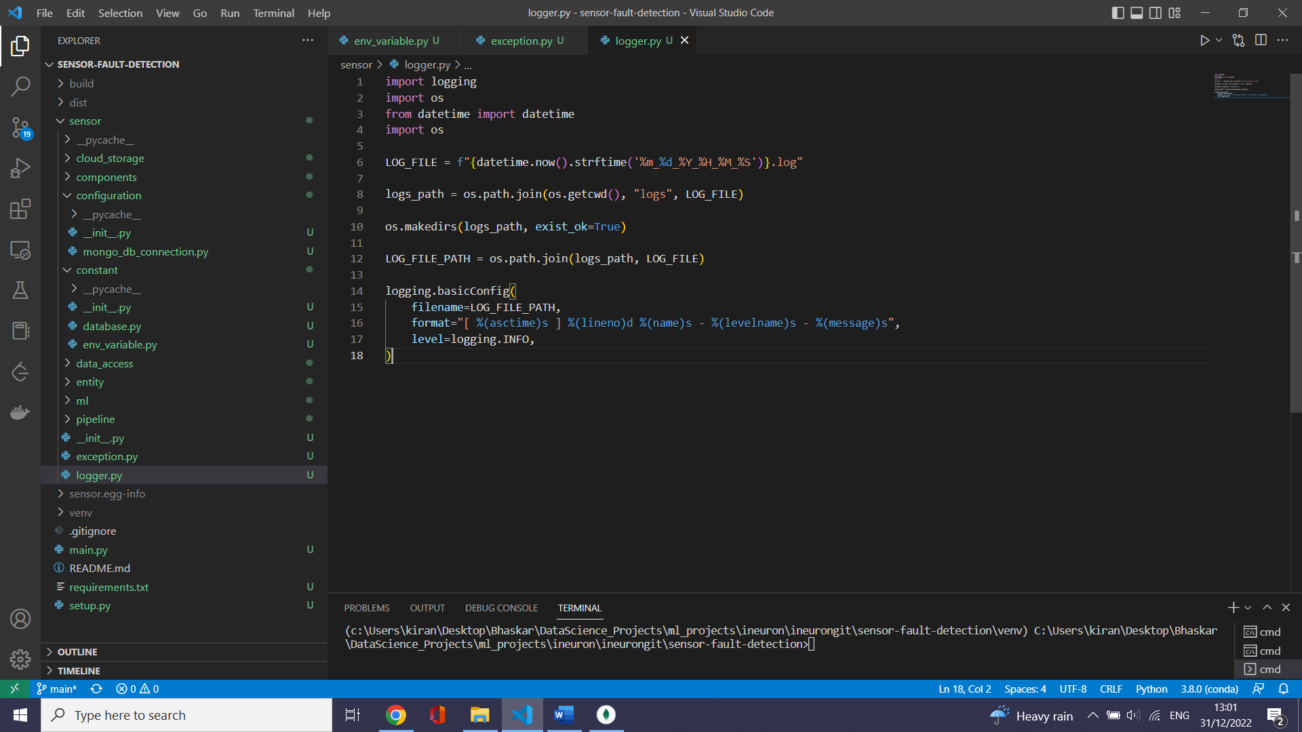

Important link for logging

<https://docs.python.org/3/library/logging.html>

# constants related to DB

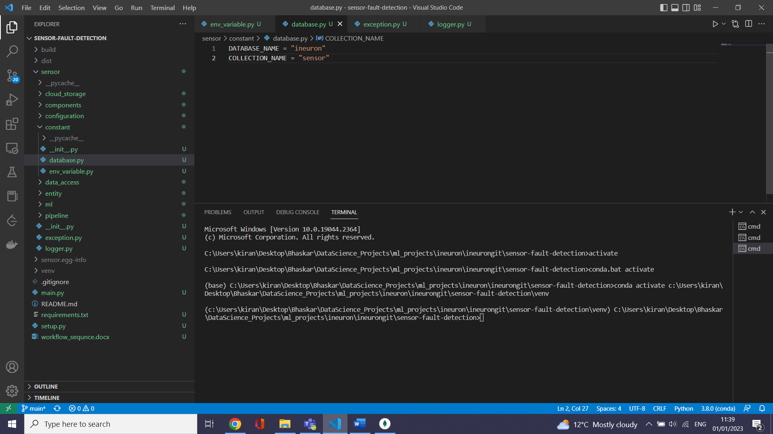

Constants related to s3 bucket:

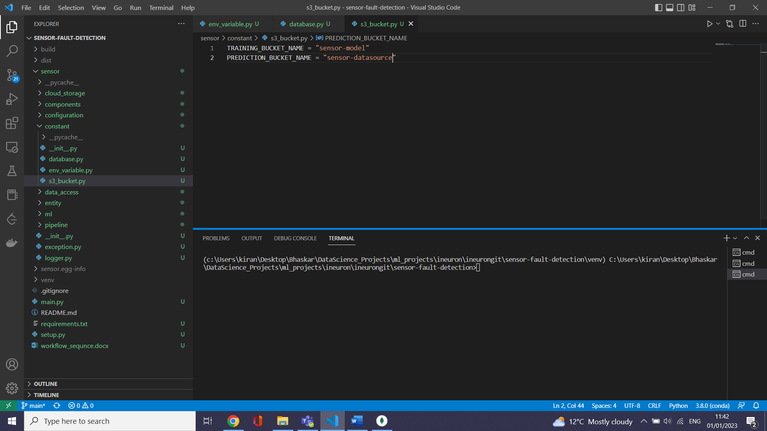

Constants related to application:

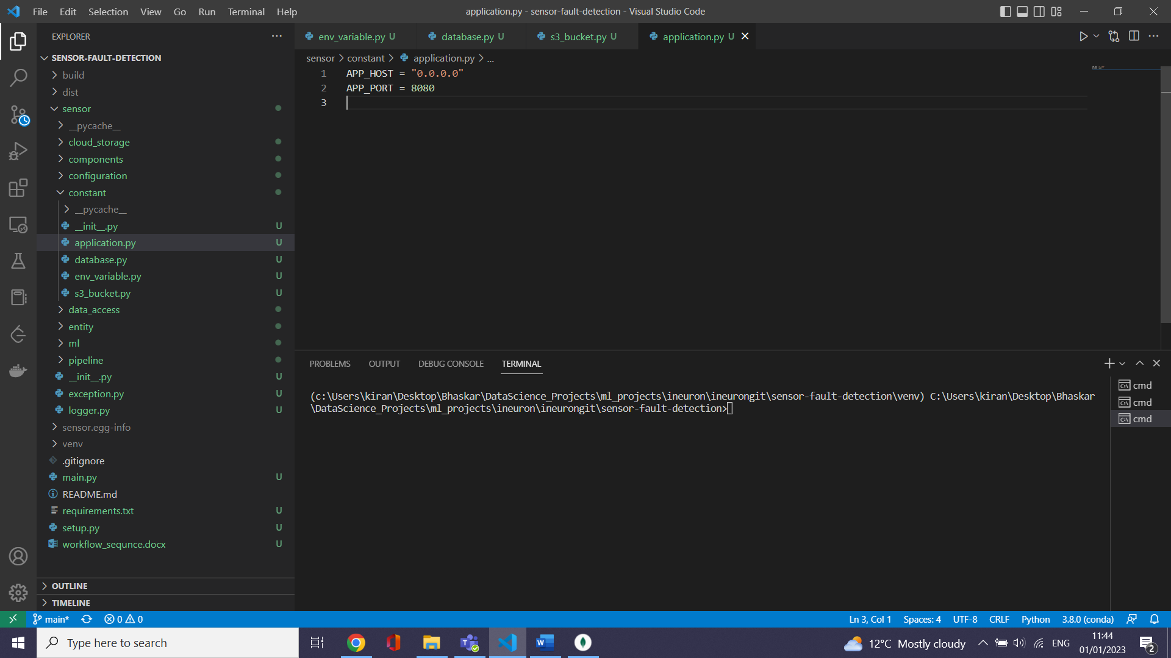

# schema.yaml in config folder to provide what the data after EDA

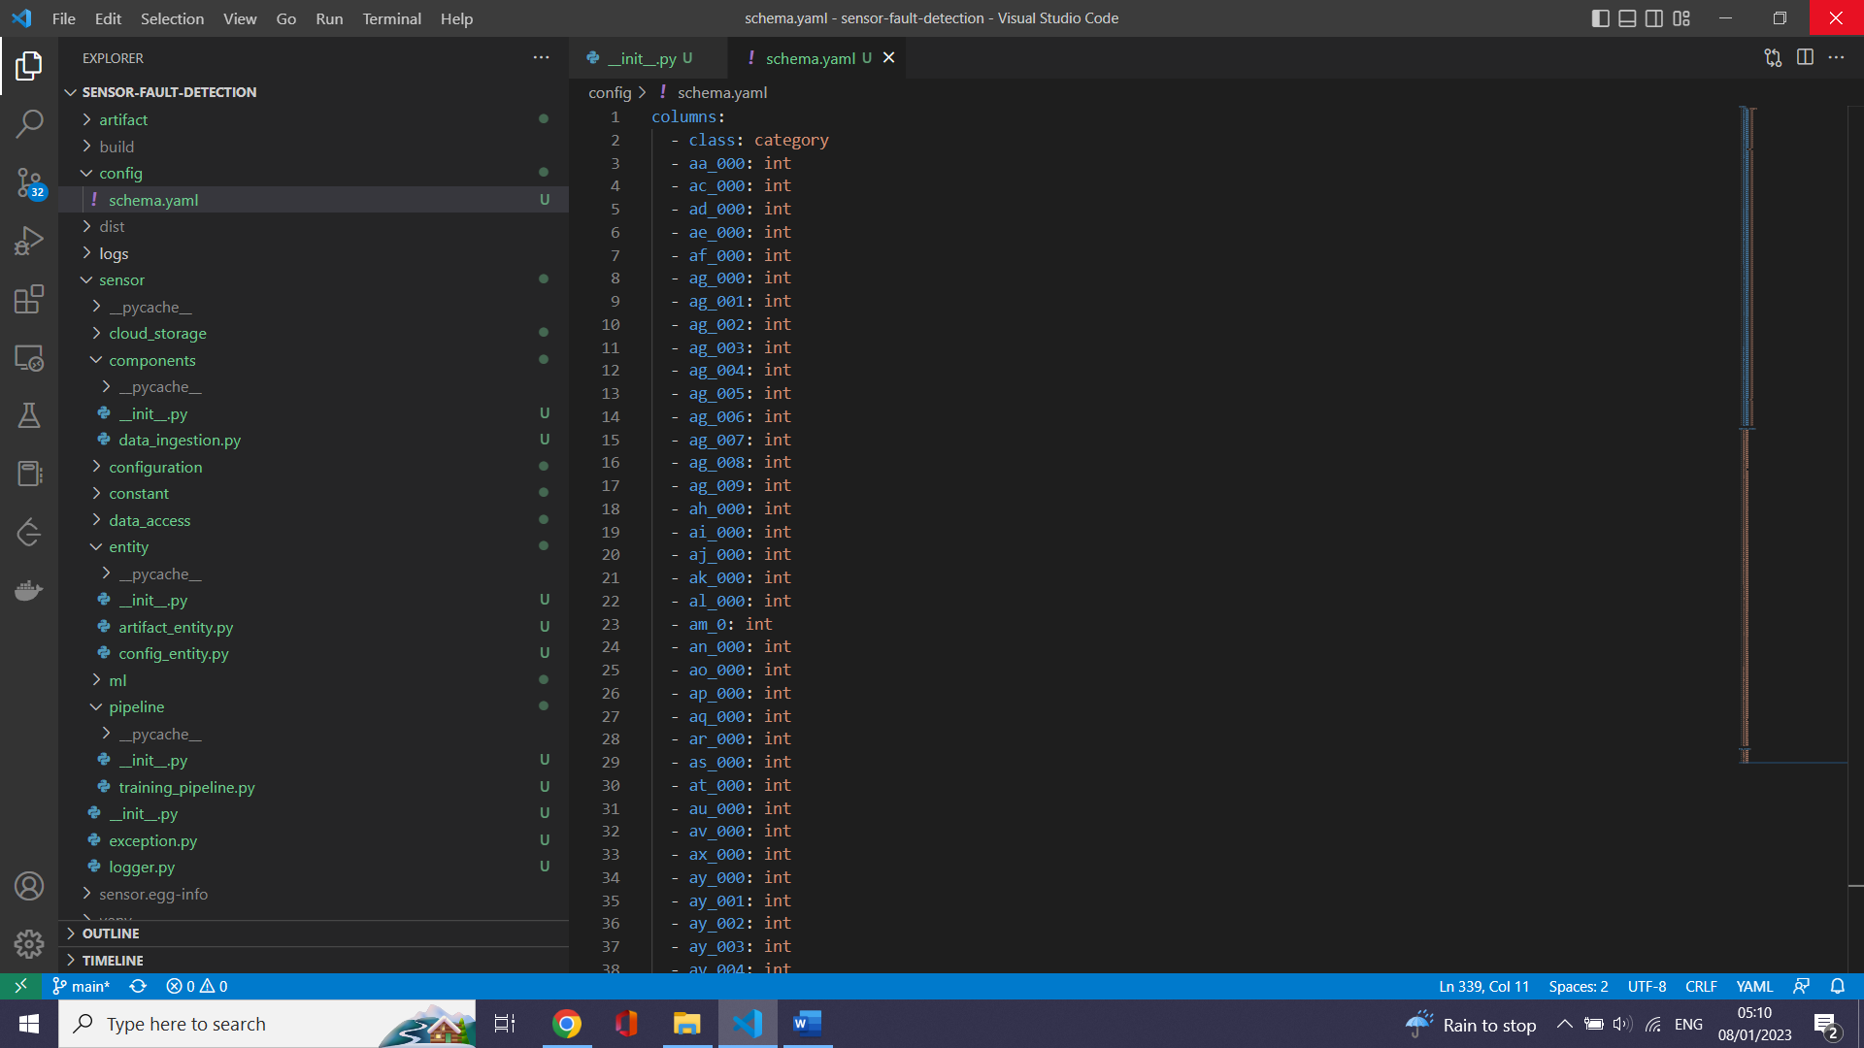

# Constants related to training pipeline

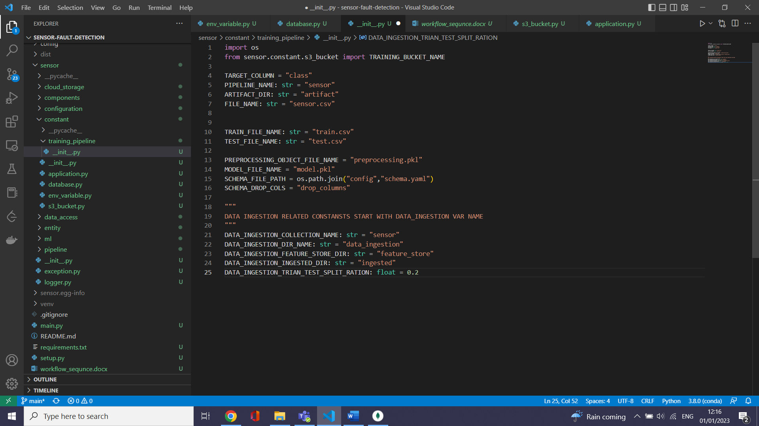

# data ingestion flow

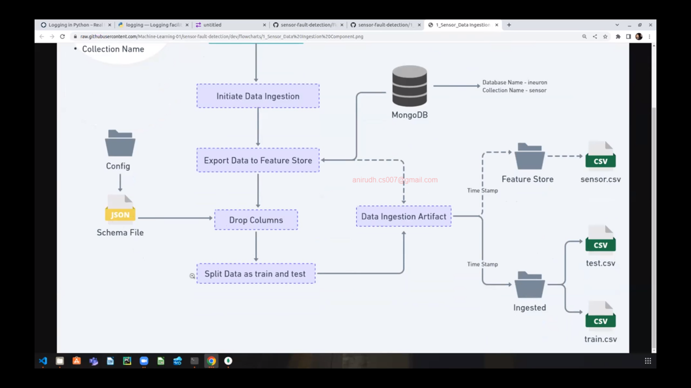

# folder structure od Data ingestion

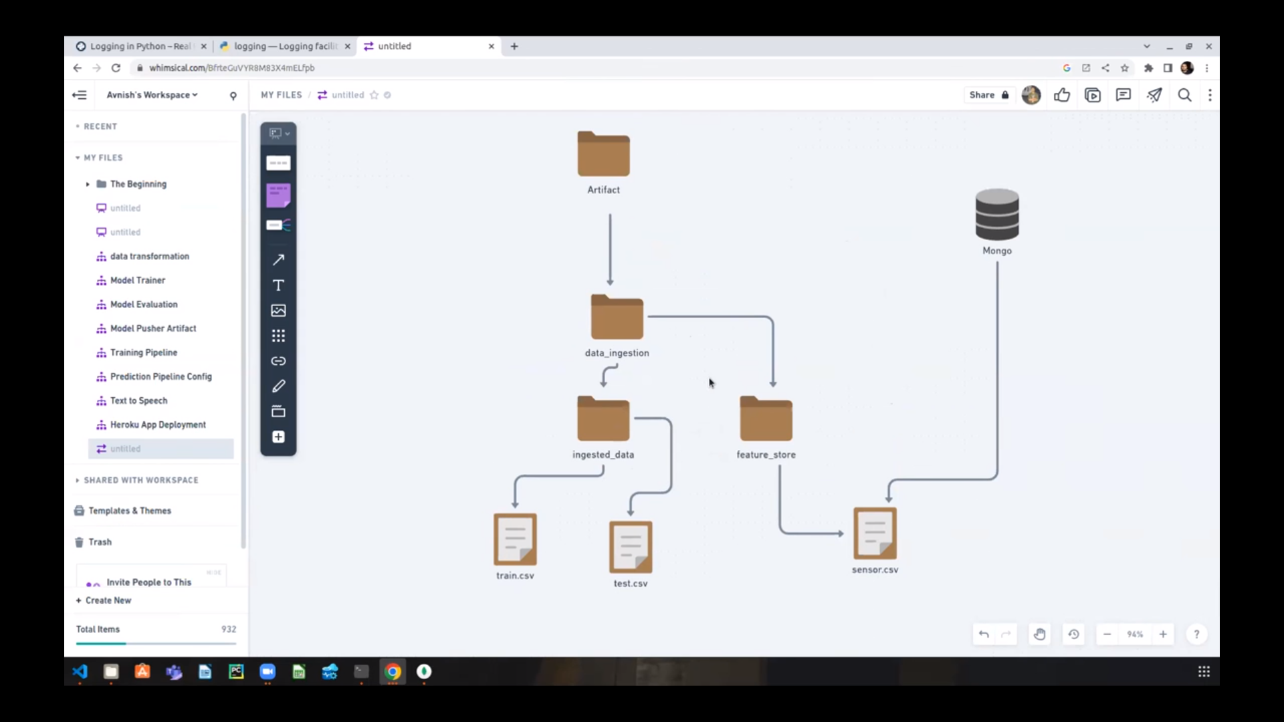

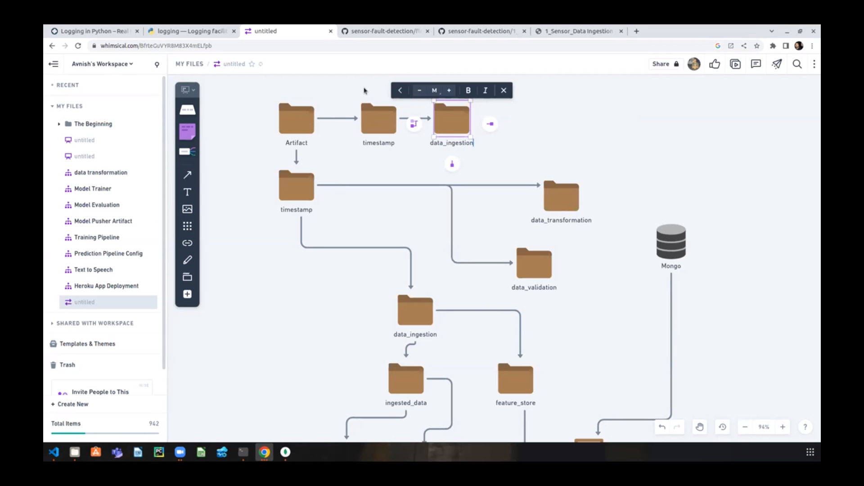

~ Defining Data ingestion config (containing Folder names )

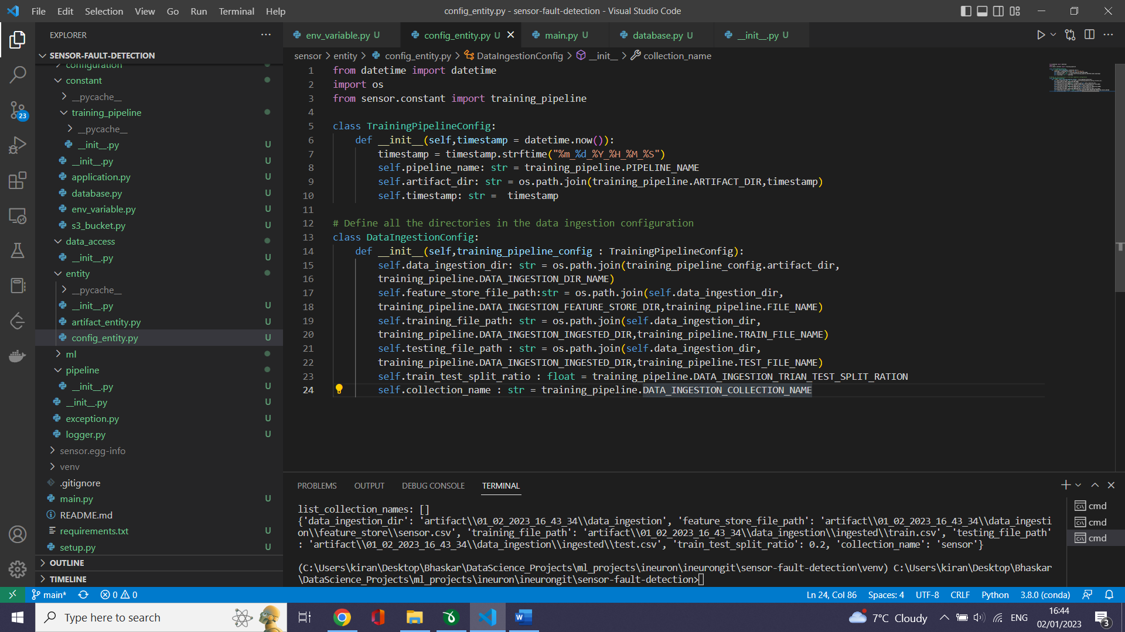

# Test Data ingestion config using main.py

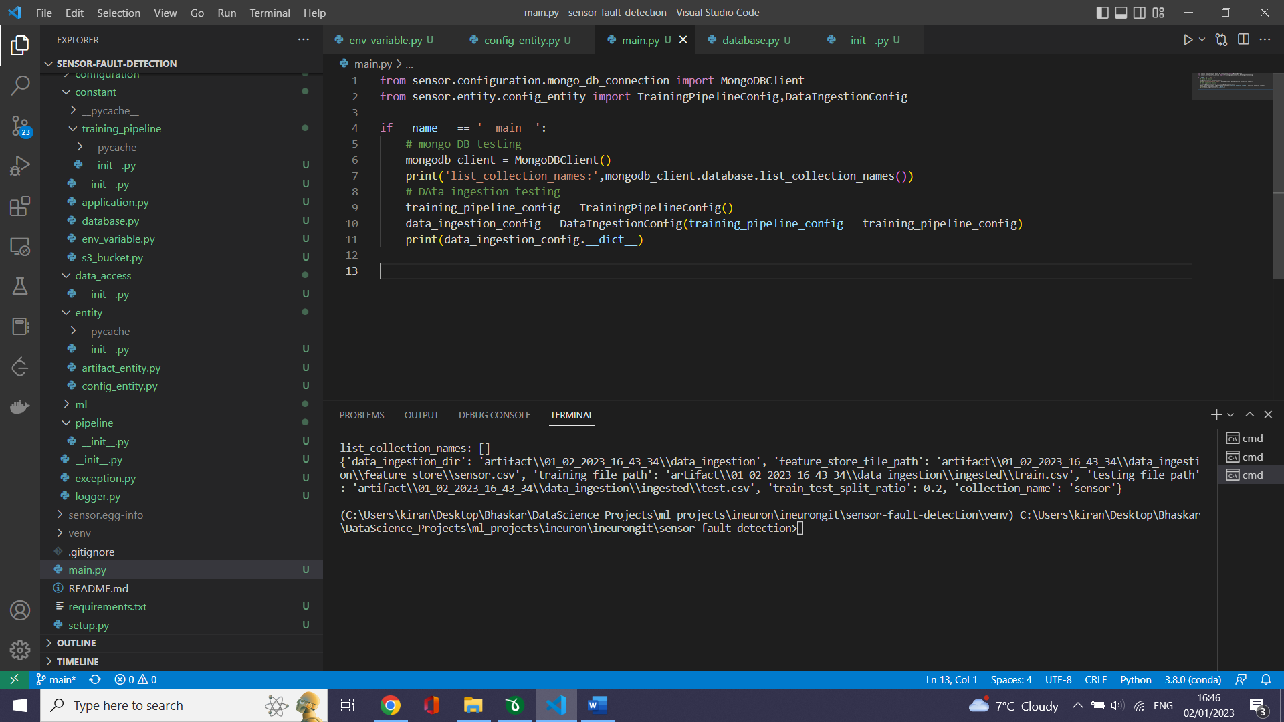

# create a data_ingestion.py under component

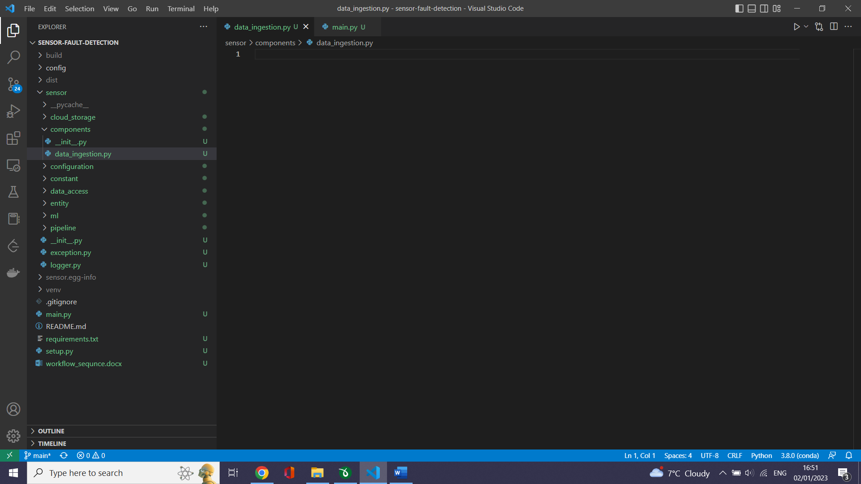

# create a training pipeline under pipeline folder. This has sequence of steps that needed to be carried out to train the model.

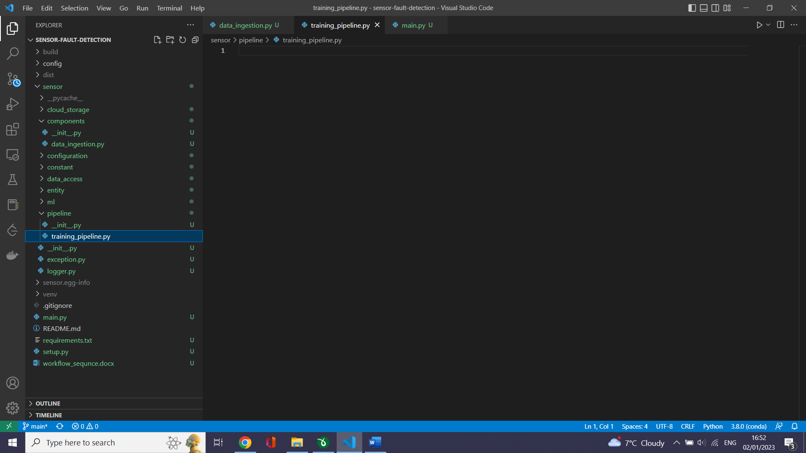

# Create the entire flow

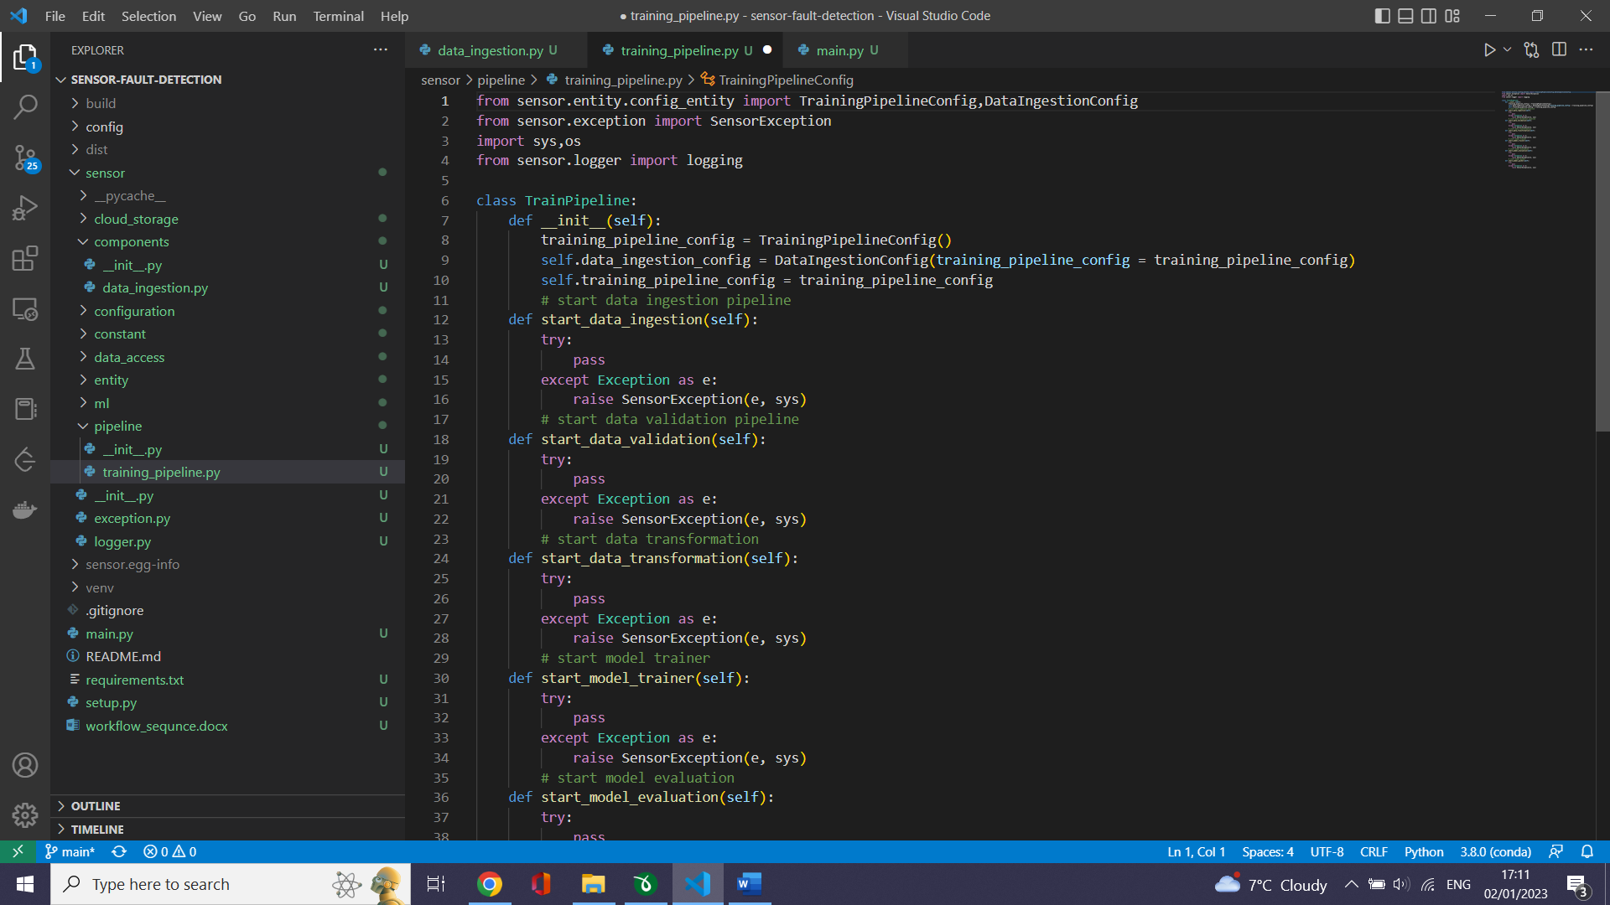

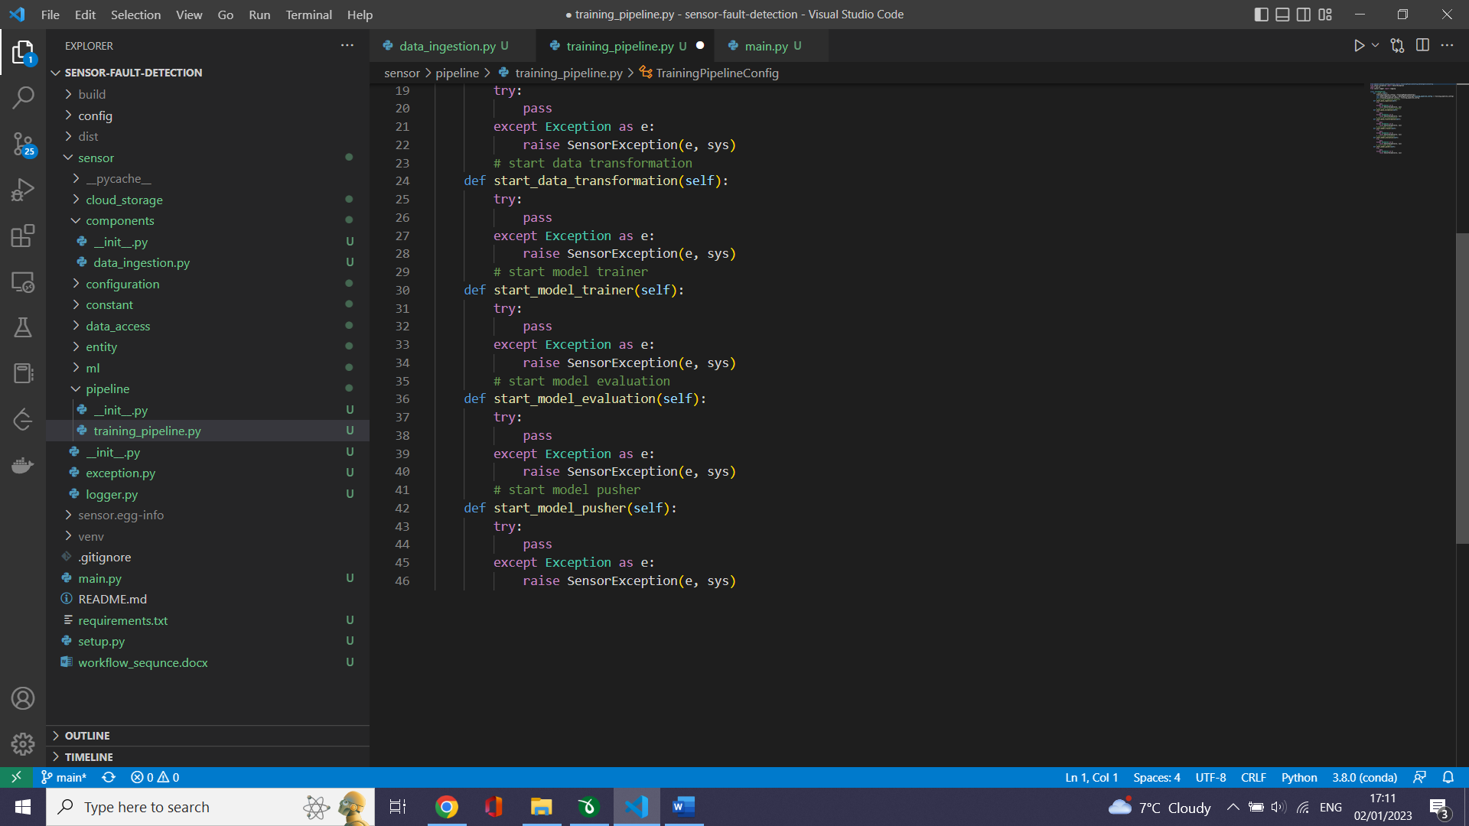

# we have to know what output we will get for each step .Data ingestion we will get the test file path and train file path

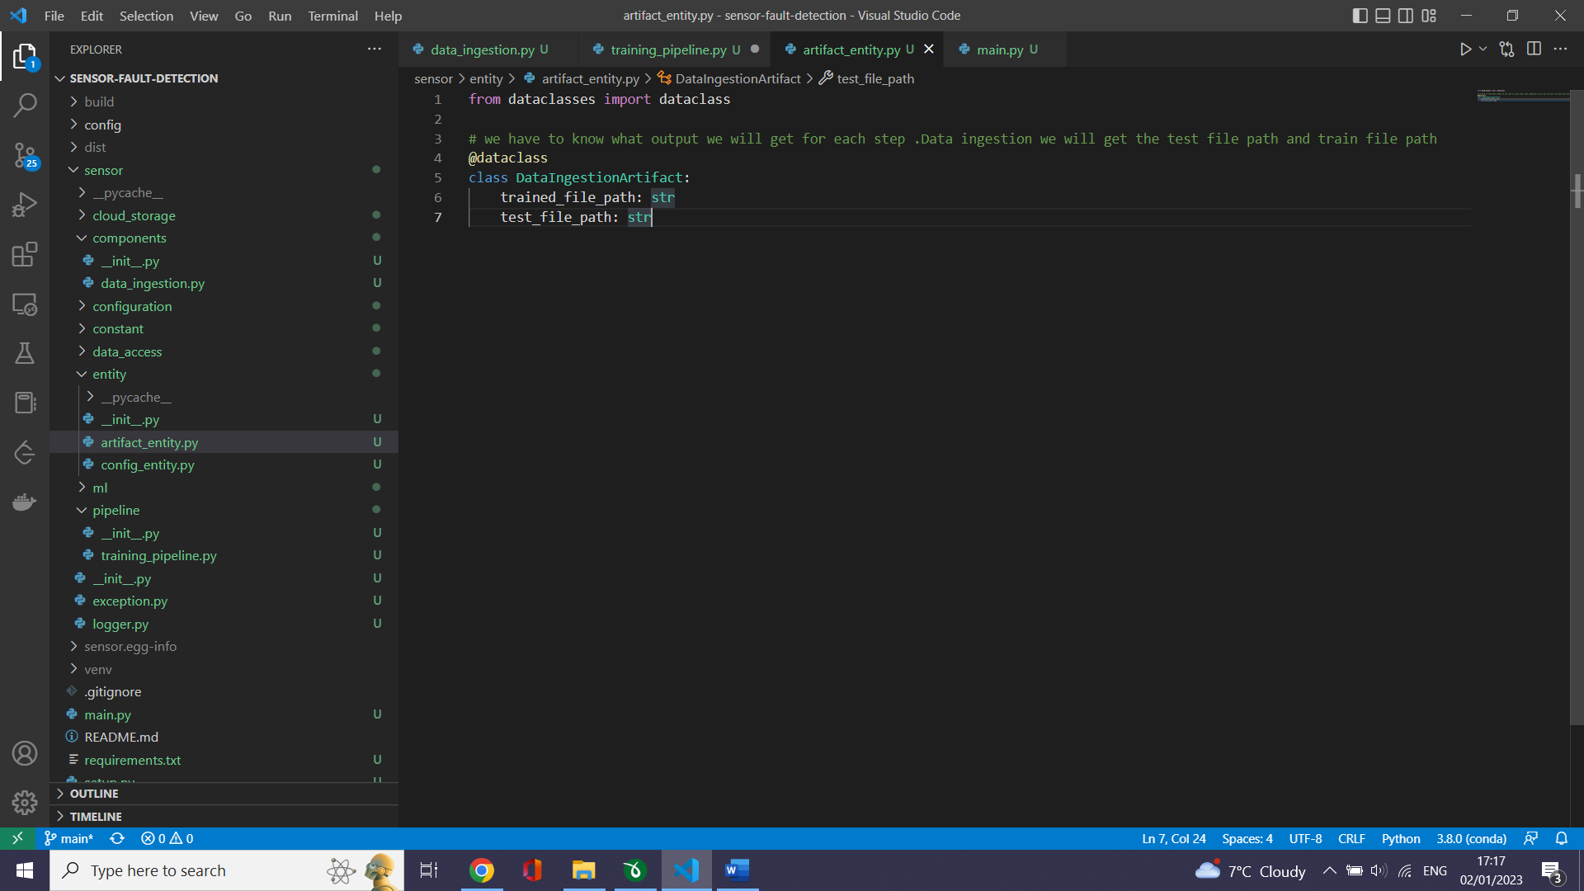

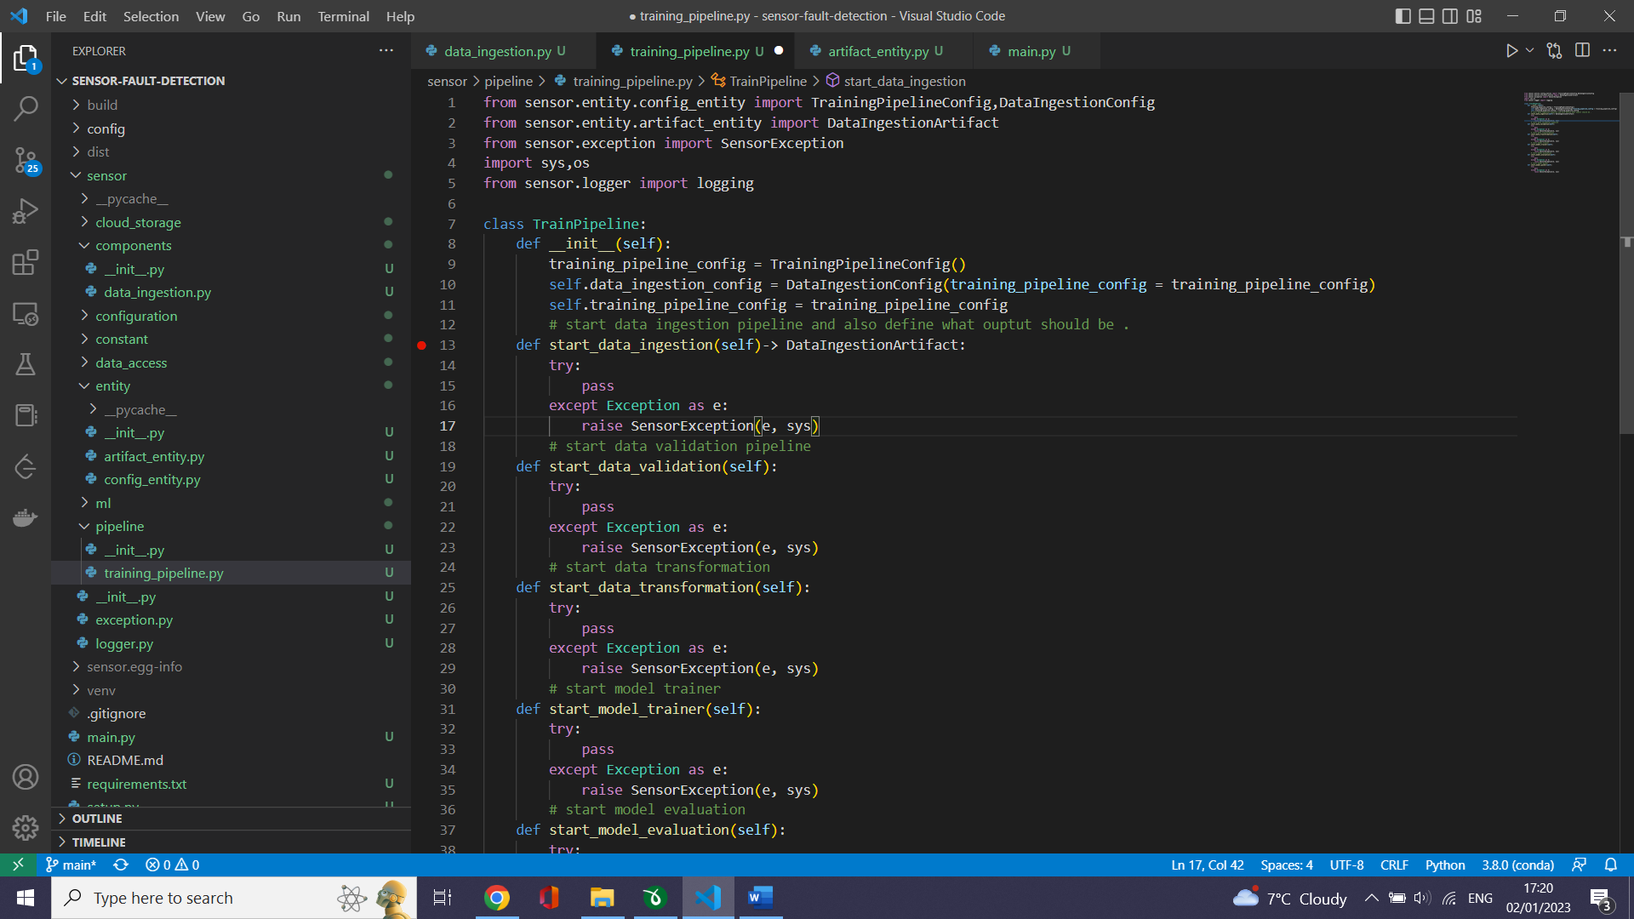

# Run data ingestion pipeline

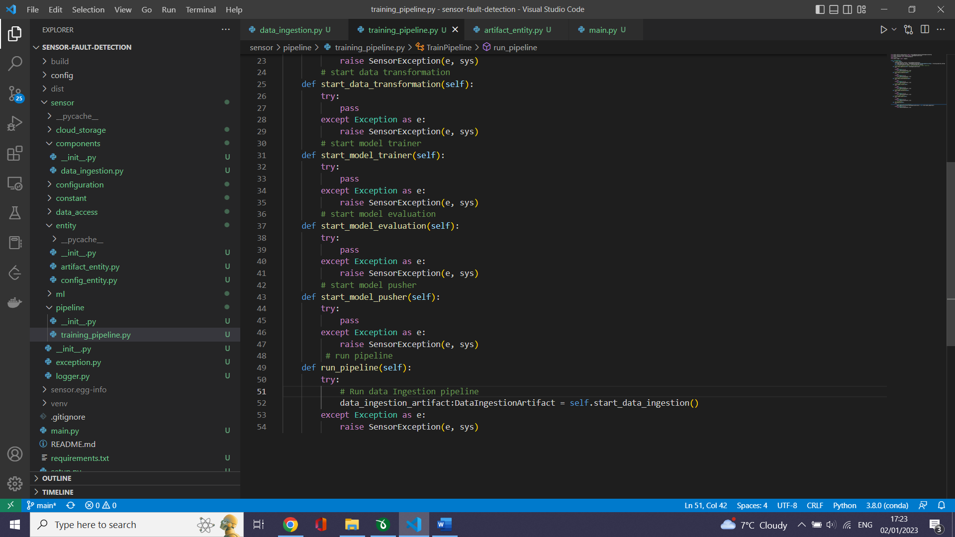

# Test the Run of training_pipeline.py

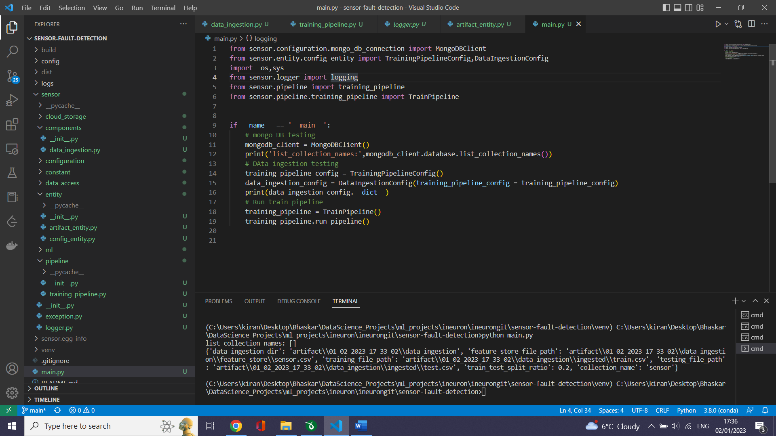

# logs

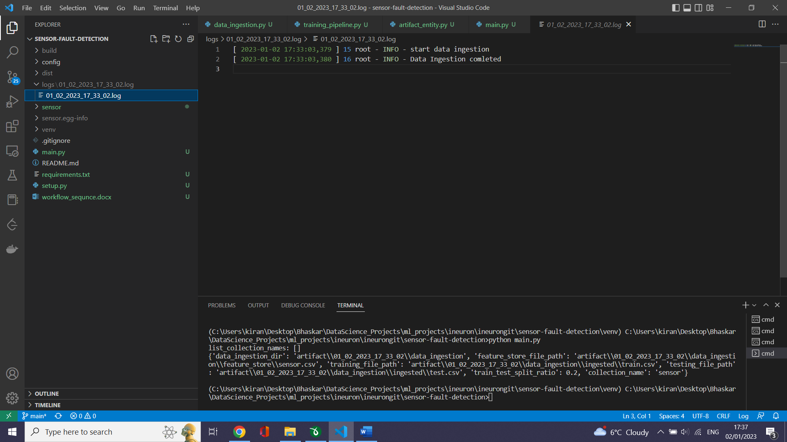

# Data ingestion

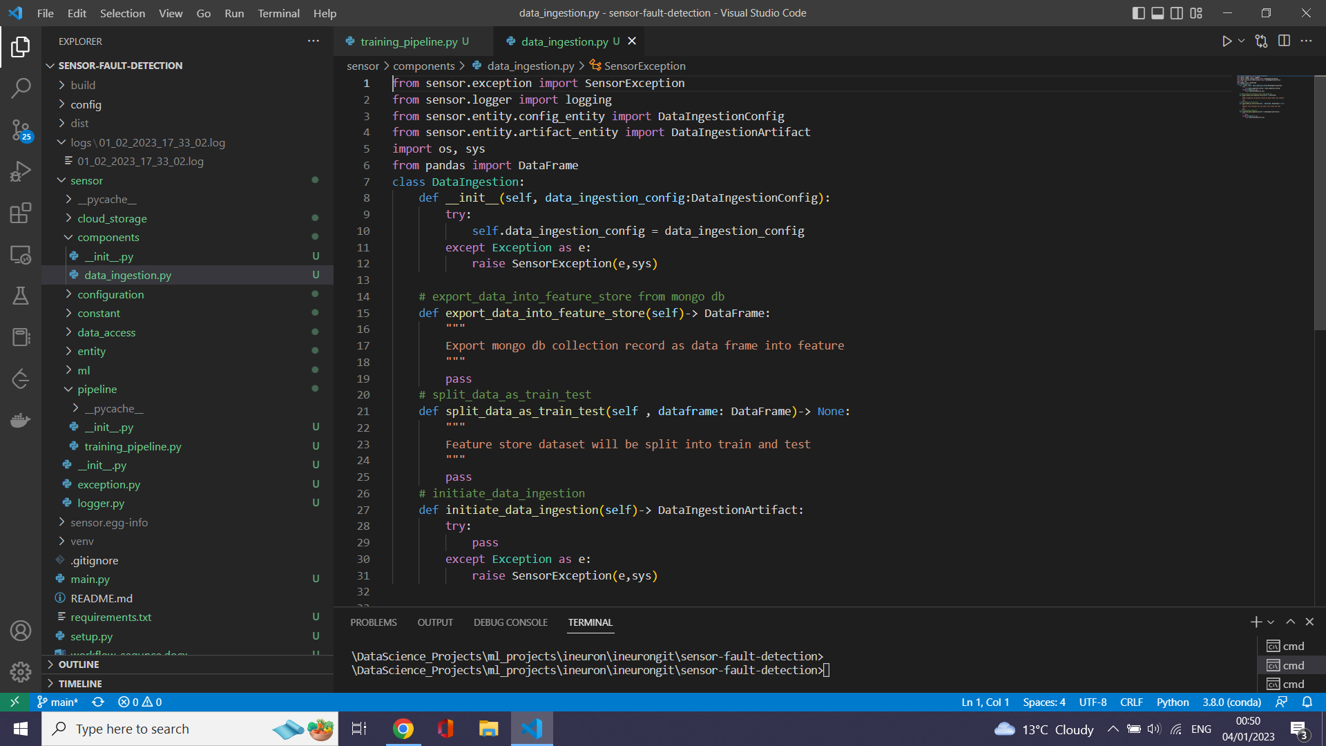

Sensor_data

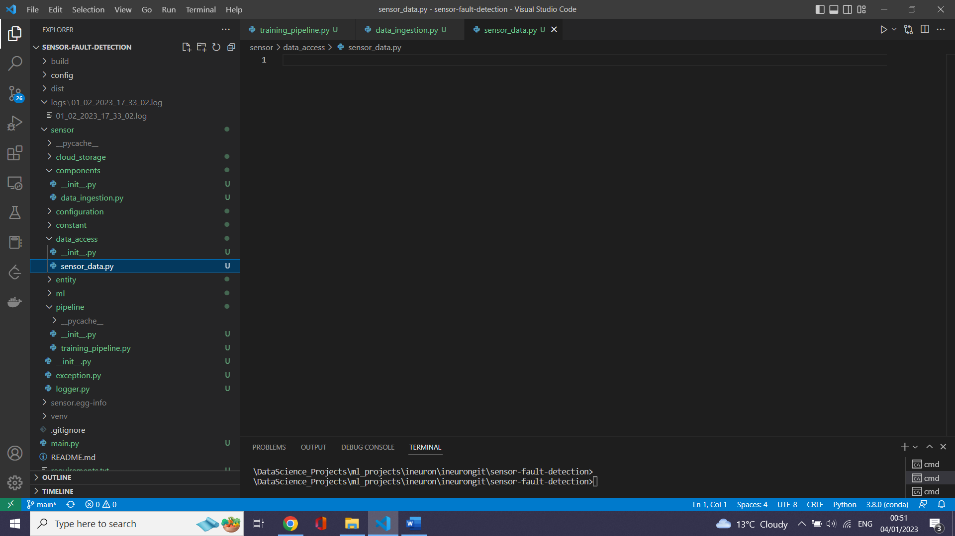

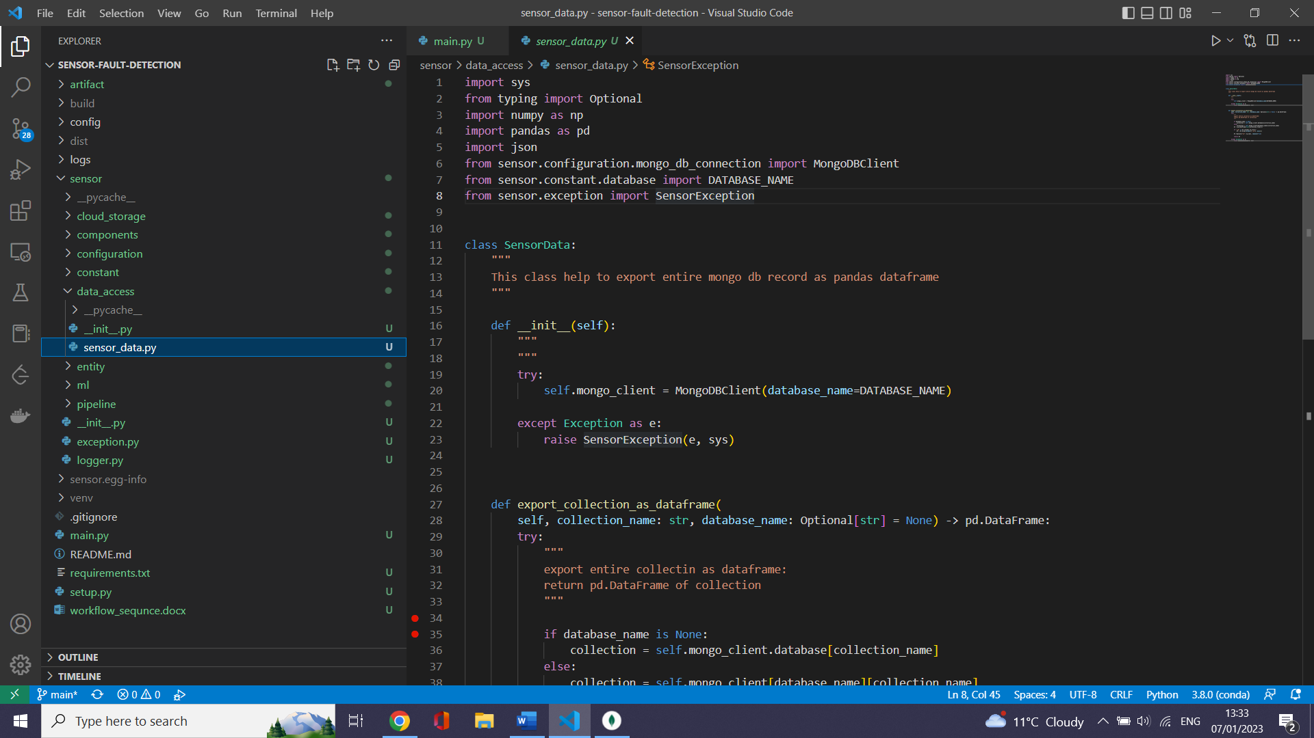

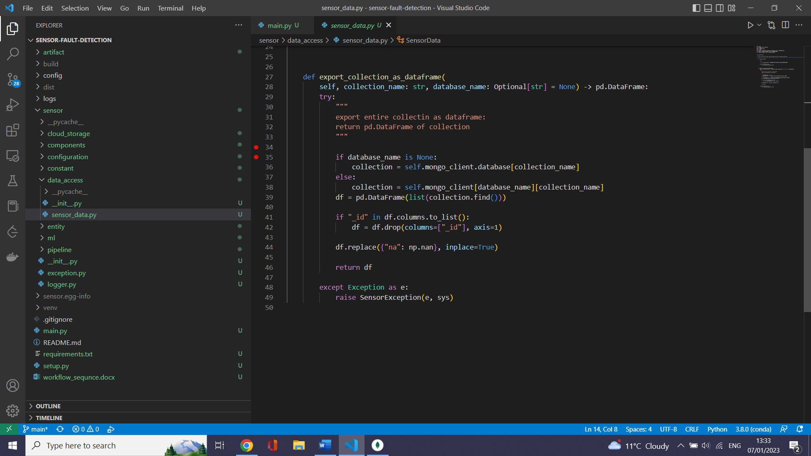

# Create data ingestion component